572 Assignment 4 Report

Zijian Li (6808755877)

Steps to complete the assignment:

1. Checked the system requirements and downloaded Apache Solr 7.1.0.zip.
2. Unzipped the solr-7.1.0 folder and cd under the directory.
3. Started Solr using the command: *bin/solr start*
4. Created a new core called myexample using the command: *bin/solr create –c myexample.*
5. Downloaded the NYD web pages data and indexed the 19620 web pages using the command: *bin/post –c myexample -filetypes html /Users/zijianli/Documents/solr-7.1.0/NYD/*
6. Cloned the solr-php-client from github using command: git clone https://github.com/PTCInc/solr-php-client
7. Created the client side PHP file according to the sample code in homework instructions.
8. Modified the PHP code to re-format the page layout, extracted title, URL (og_url), id and description from the JSON result. Tested the web page.
9. According to the sample code provided in assignment instruction, created a java file to get the edgeList.txt.
10. In the java code, I used two HashMap to construct (file, url) pairs and (url, file) pairs through the given .csv file.
11. Then I used *org.jsoup.nodes.Document* package to parse all the html files in the .csv file and used *org.jsoup.select.Elements* to extract all the links in the html files.
12. Store all the links into “edgeList.txt” using the two HashMaps.
13. After constructing the “edgeList.txt” file, I implemented a Python file according to the instructions. The Python program used networkx library, and the parameters are: *alpha=0.85, personalization=None, max_iter=30, tol=1e-06, nstart=None, weight='weight', dangling=None*
14. Used the Python program to extract the “external_pageRankFile.txt” which contains the page rank values of all the html pages. Put the “external_pageRankFile.txt” file under the data folder of the *myexample* core
15. Added the following fields into the manage-schema file under the conf folder of the core:

<fieldType name="external" keyField="id" defVal="0" class="solr.ExternalFileField"/>

<field name="pageRankFile" type="external" stored="false" indexed="false"/>

1. Added the following listeners to solrconfig.xml:

<listener event="newSearcher" class="org.apache.solr.schema.ExternalFileFieldReloader"/>

<listener event="firstSearcher" class="org.apache.solr.schema.ExternalFileFieldReloader"/>

1. Reloaded the core in core admin.
2. Added additional parameter “sort => pageRankFile desc” in the PHP file and modified the PHP files with some CSS style. I modified the web pages into two parts, the left side of the page are Solr Lucene results, and the right side are PageRank results. Both of the two method’s results are shown on the page at the same time.

Question: why some pages have higher PageRank values than others?

Explanation: Some pages have higher page rank values than others is because that those pages are cited more than others. In other words, they have more incoming links.

Screenshots:

Initial page:



Queries:

The pages are two main parts, left side is solr internal searching results, right side are Page rank searching results

1. **Elon Mask**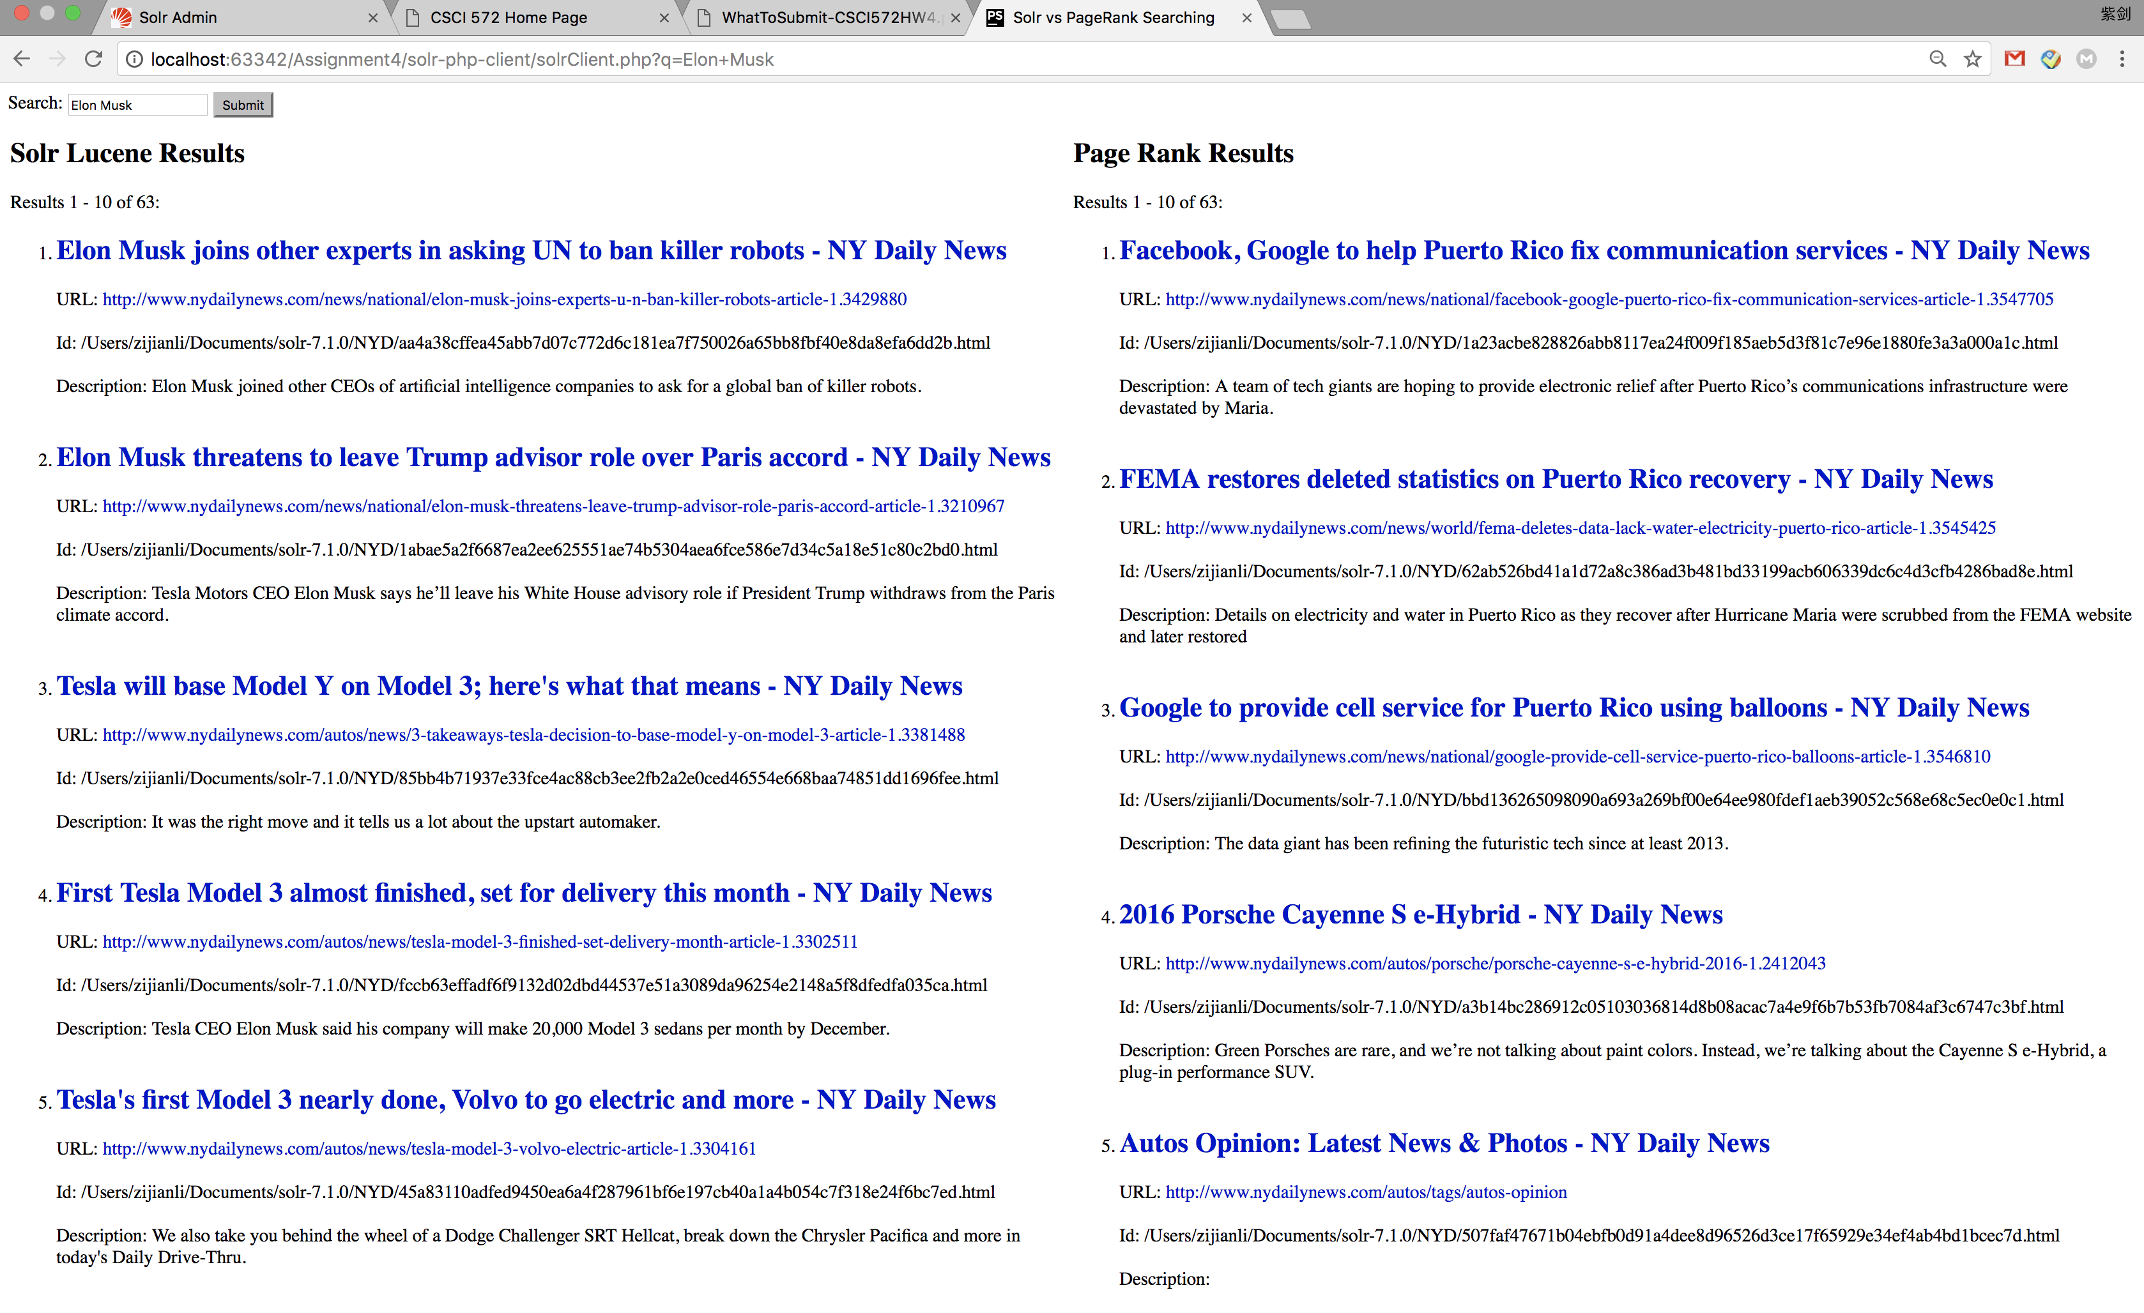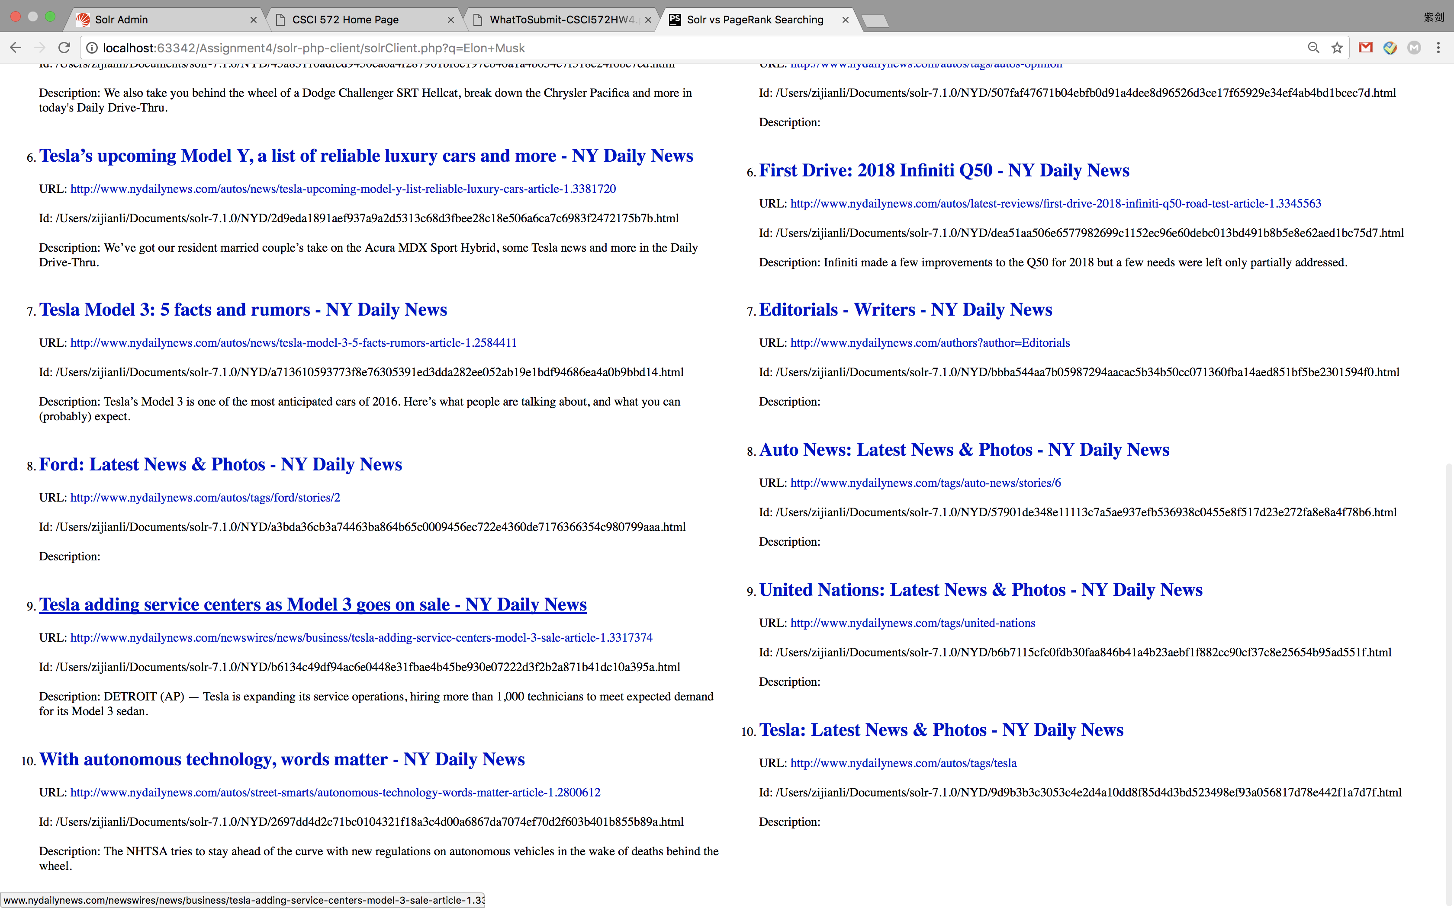

Page of

[First Tesla Model 3 almost finished, set for delivery this month - NY Daily News](http://www.nydailynews.com/autos/news/tesla-model-3-finished-set-delivery-month-article-1.3302511)

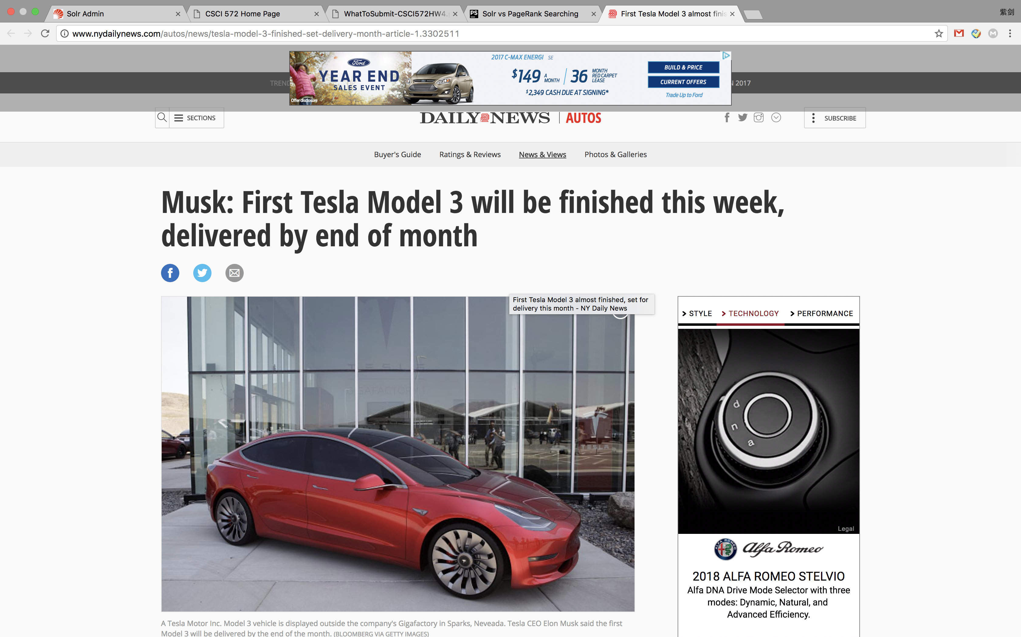

Page of: [Facebook, Google to help Puerto Rico fix communication services - NY Daily News](http://www.nydailynews.com/news/national/facebook-google-puerto-rico-fix-communication-services-article-1.3547705)

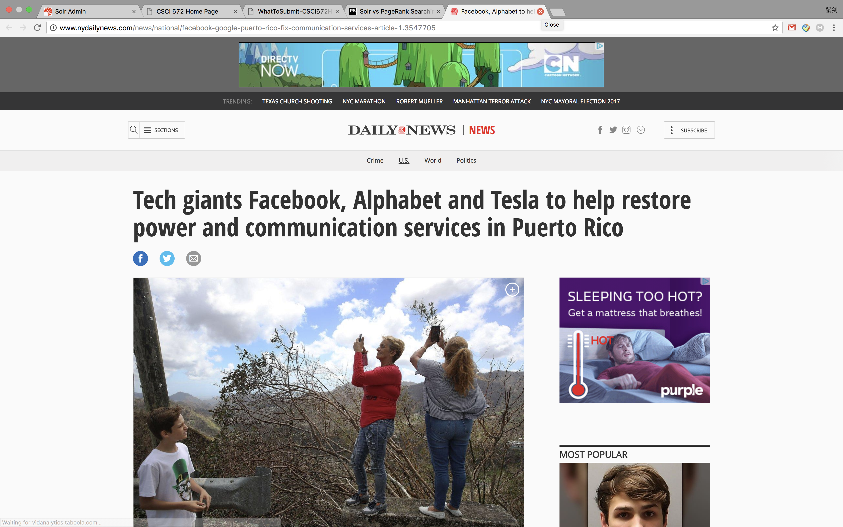

Result URLs:

Solr Internal:

1. <http://www.nydailynews.com/news/national/elon-musk-joins-experts-u-n-ban-killer-robots-article-1.3429880>
2. <http://www.nydailynews.com/news/national/elon-musk-threatens-leave-trump-advisor-role-paris-accord-article-1.3210967>
3. <http://www.nydailynews.com/autos/news/3-takeaways-tesla-decision-to-base-model-y-on-model-3-article-1.3381488>
4. <http://www.nydailynews.com/autos/news/tesla-model-3-finished-set-delivery-month-article-1.3302511>
5. <http://www.nydailynews.com/autos/news/tesla-model-3-volvo-electric-article-1.3304161>
6. <http://www.nydailynews.com/autos/news/tesla-upcoming-model-y-list-reliable-luxury-cars-article-1.3381720>
7. <http://www.nydailynews.com/autos/news/tesla-model-3-5-facts-rumors-article-1.2584411>
8. <http://www.nydailynews.com/autos/tags/ford/stories/2>
9. <http://www.nydailynews.com/newswires/news/business/tesla-adding-service-centers-model-3-sale-article-1.3317374>
10. <http://www.nydailynews.com/autos/street-smarts/autonomous-technology-words-matter-article-1.2800612>

Page Rank:

1. <http://www.nydailynews.com/news/national/facebook-google-puerto-rico-fix-communication-services-article-1.3547705>
2. <http://www.nydailynews.com/news/world/fema-deletes-data-lack-water-electricity-puerto-rico-article-1.3545425>
3. <http://www.nydailynews.com/news/national/google-provide-cell-service-puerto-rico-balloons-article-1.3546810>
4. <http://www.nydailynews.com/autos/porsche/porsche-cayenne-s-e-hybrid-2016-1.2412043>
5. <http://www.nydailynews.com/autos/tags/autos-opinion>
6. <http://www.nydailynews.com/autos/latest-reviews/first-drive-2018-infiniti-q50-road-test-article-1.3345563>
7. <http://www.nydailynews.com/authors?author=Editorials>
8. <http://www.nydailynews.com/tags/auto-news/stories/6>
9. <http://www.nydailynews.com/tags/united-nations>
10. <http://www.nydailynews.com/autos/tags/tesla>

**Star Wars:**

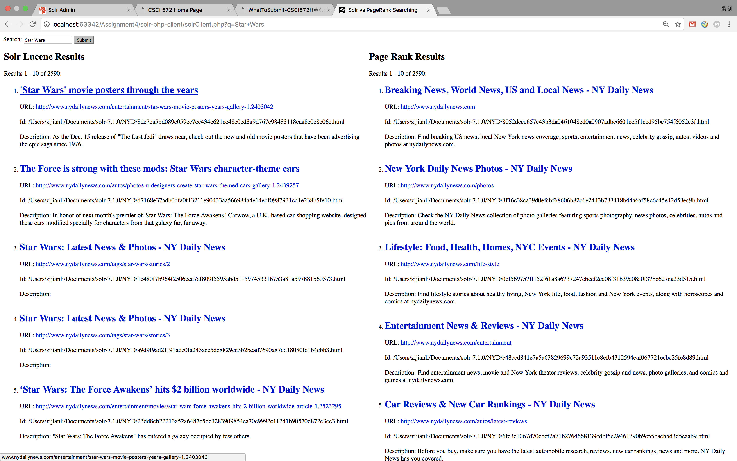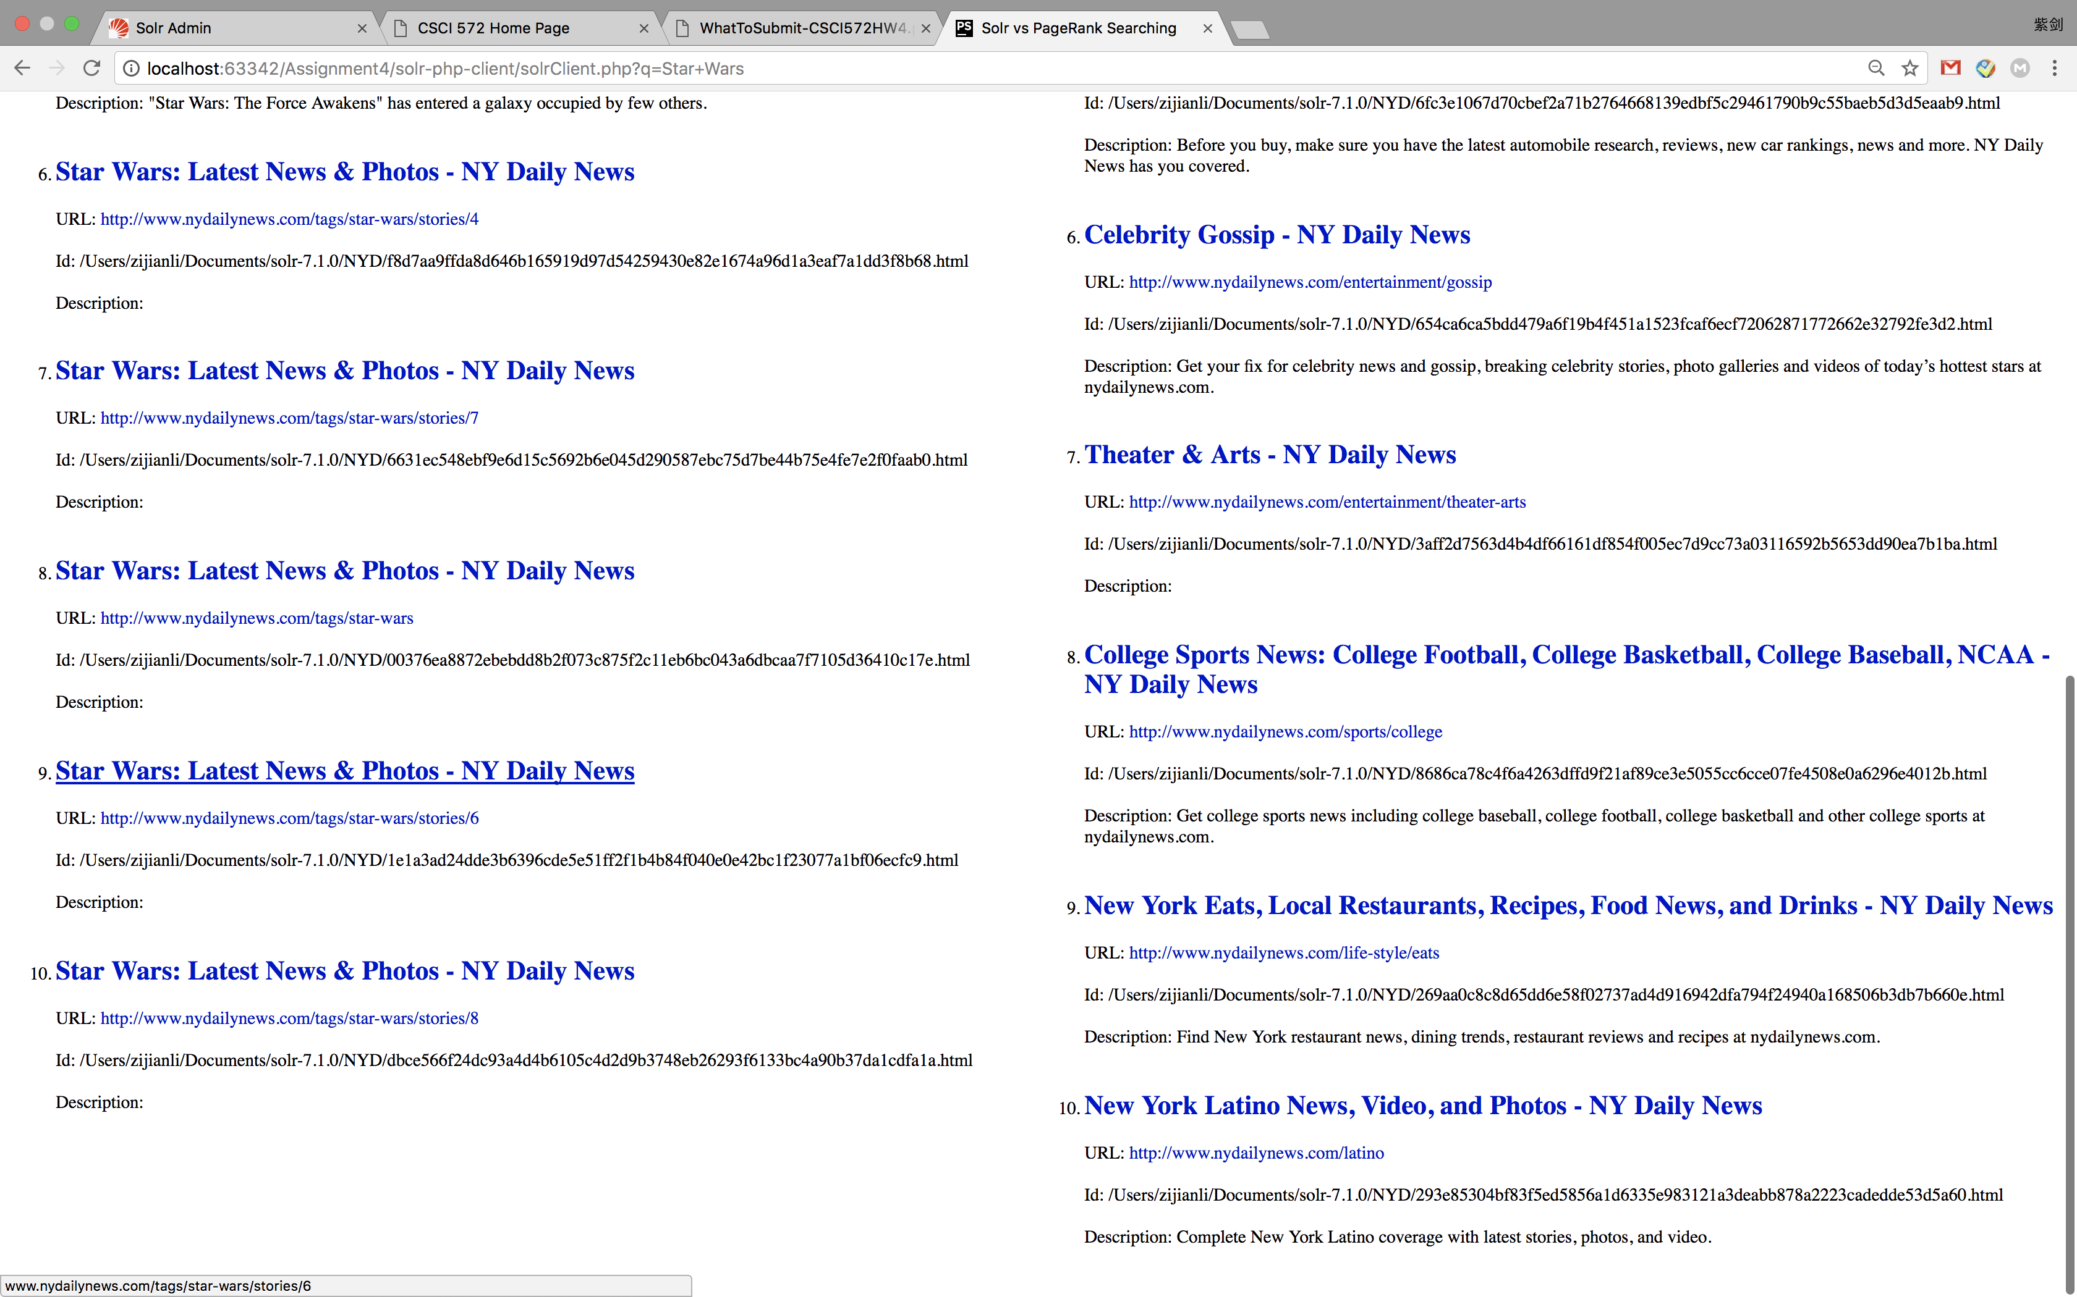

Page of:  ['Star Wars' movie posters through the years ](http://www.nydailynews.com/entertainment/star-wars-movie-posters-years-gallery-1.2403042)

Page of: [Lifestyle: Food, Health, Homes, NYC Events - NY Daily News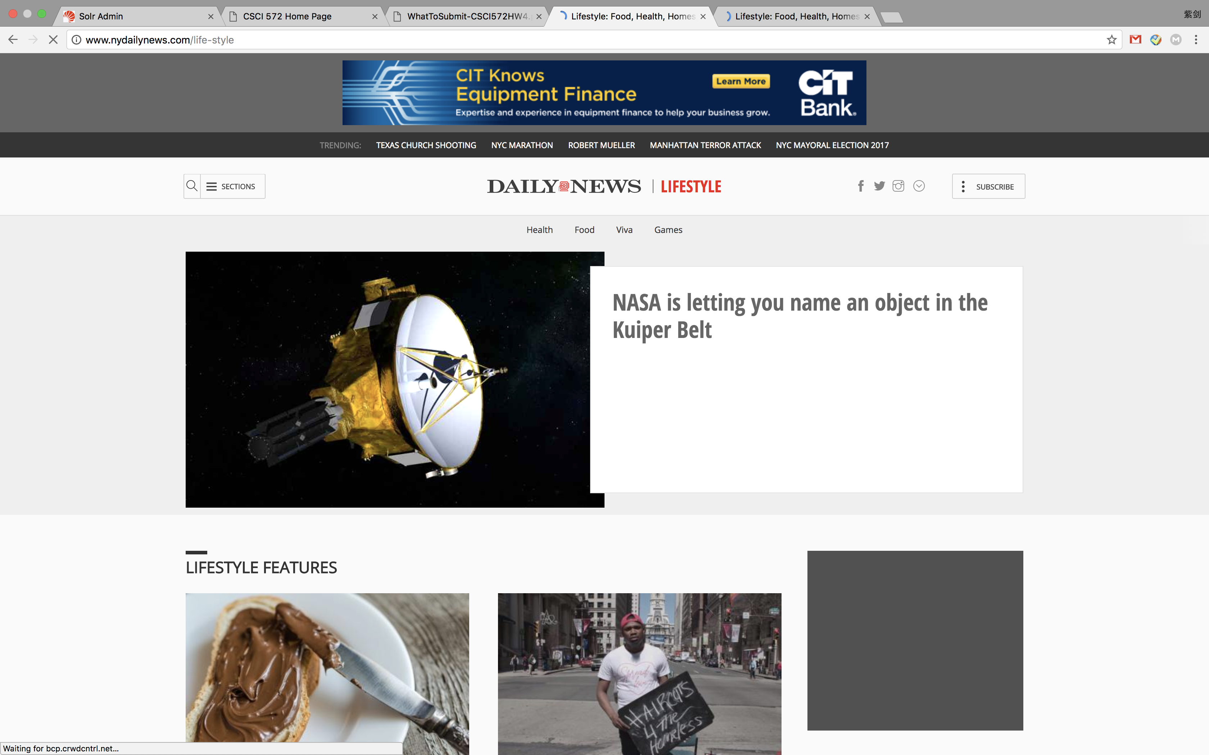](http://www.nydailynews.com/life-style)

Result URLs:

Solr Internal:

1. URL: <http://www.nydailynews.com/entertainment/star-wars-movie-posters-years-gallery-1.2403042>
2. URL: <http://www.nydailynews.com/autos/photos-u-designers-create-star-wars-themed-cars-gallery-1.2439257>
3. URL: <http://www.nydailynews.com/tags/star-wars/stories/2>
4. URL: <http://www.nydailynews.com/tags/star-wars/stories/3>
5. URL: <http://www.nydailynews.com/entertainment/movies/star-wars-force-awakens-hits-2-billion-worldwide-article-1.2523295>
6. URL: <http://www.nydailynews.com/tags/star-wars/stories/4>
7. URL: <http://www.nydailynews.com/tags/star-wars/stories/7>
8. URL: <http://www.nydailynews.com/tags/star-wars>
9. URL: <http://www.nydailynews.com/tags/star-wars/stories/6>
10. URL: <http://www.nydailynews.com/tags/star-wars/stories/8>

Page Rank:

1. URL: [http://www.nydailynews.com](http://www.nydailynews.com/)
2. URL: <http://www.nydailynews.com/photos>
3. URL: <http://www.nydailynews.com/life-style>
4. URL: <http://www.nydailynews.com/entertainment>
5. URL: <http://www.nydailynews.com/autos/latest-reviews>
6. URL: <http://www.nydailynews.com/entertainment/gossip>
7. URL: <http://www.nydailynews.com/entertainment/theater-arts>
8. URL: <http://www.nydailynews.com/sports/college>
9. URL: <http://www.nydailynews.com/life-style/eats>
10. URL: <http://www.nydailynews.com/latino>

**North Korea:**

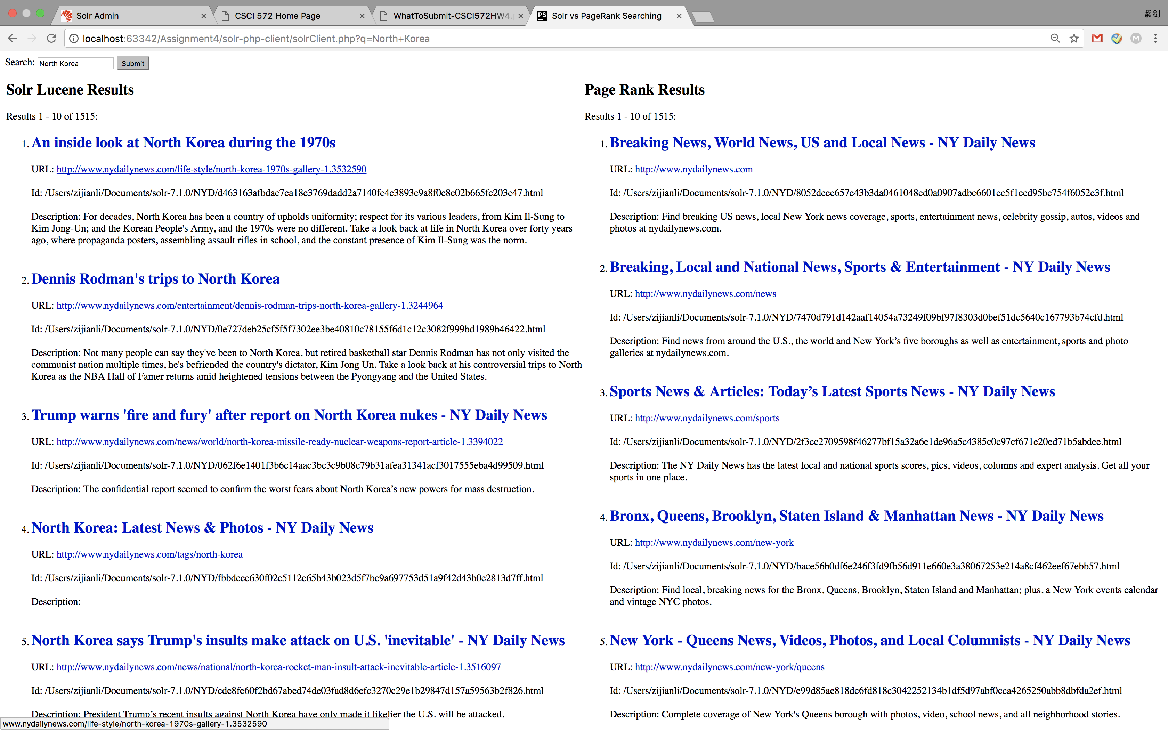 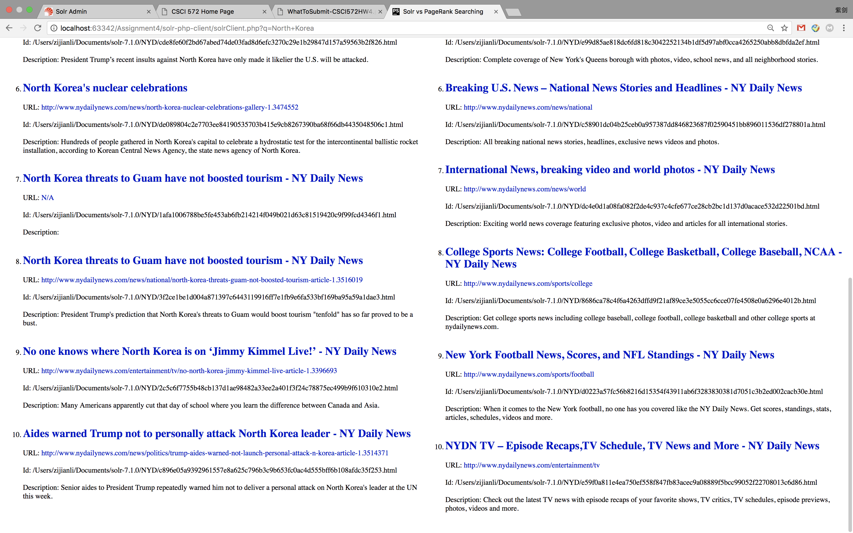

Page:  [Dennis Rodman's trips to North Korea ](http://www.nydailynews.com/entertainment/dennis-rodman-trips-north-korea-gallery-1.3244964)

Page:  [Bronx, Queens, Brooklyn, Staten Island & Manhattan News - NY DailyNews 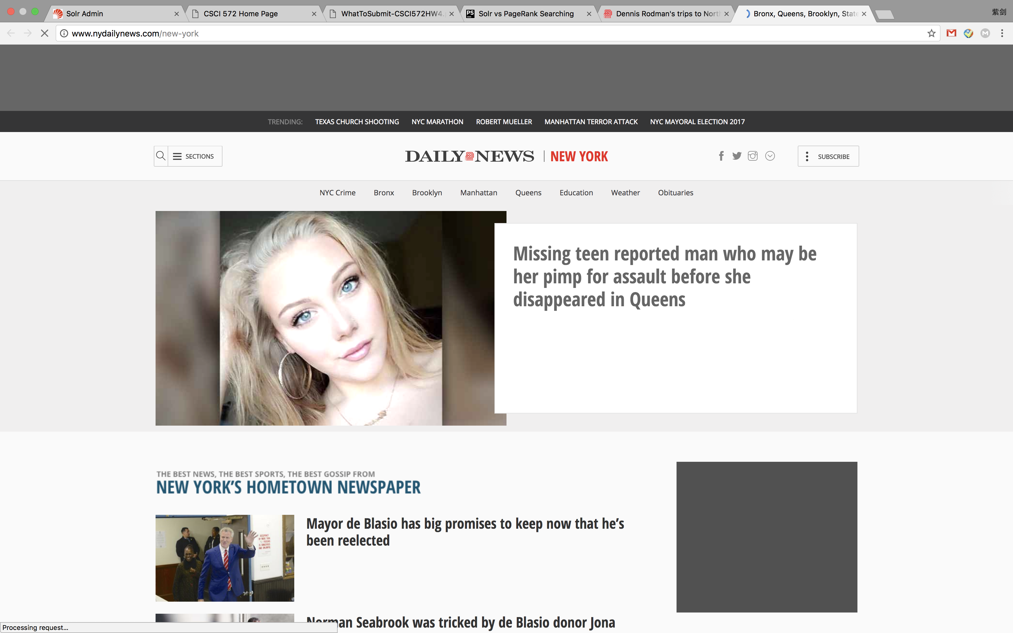](http://www.nydailynews.com/new-york)

Solr Result:

1. URL: <http://www.nydailynews.com/life-style/north-korea-1970s-gallery-1.3532590>
2. URL: <http://www.nydailynews.com/entertainment/dennis-rodman-trips-north-korea-gallery-1.3244964>
3. URL: <http://www.nydailynews.com/news/world/north-korea-missile-ready-nuclear-weapons-report-article-1.3394022>
4. URL: <http://www.nydailynews.com/tags/north-korea>
5. URL: <http://www.nydailynews.com/news/national/north-korea-rocket-man-insult-attack-inevitable-article-1.3516097>
6. URL: <http://www.nydailynews.com/news/north-korea-nuclear-celebrations-gallery-1.3474552>
7. URL: [N/A](http://localhost:63342/Assignment4/solr-php-client/N/A)
8. URL: <http://www.nydailynews.com/news/national/north-korea-threats-guam-not-boosted-tourism-article-1.3516019>
9. URL: <http://www.nydailynews.com/entertainment/tv/no-north-korea-jimmy-kimmel-live-article-1.3396693>
10. URL: <http://www.nydailynews.com/news/politics/trump-aides-warned-not-launch-personal-attack-n-korea-article-1.3514371>

Page Rank:

1. URL: [http://www.nydailynews.com](http://www.nydailynews.com/)
2. URL: <http://www.nydailynews.com/news>
3. URL: <http://www.nydailynews.com/sports>
4. URL: <http://www.nydailynews.com/new-york>
5. URL: <http://www.nydailynews.com/new-york/queens>
6. URL: <http://www.nydailynews.com/news/national>
7. URL: <http://www.nydailynews.com/news/world>
8. URL: <http://www.nydailynews.com/sports/college>
9. URL: <http://www.nydailynews.com/sports/football>
10. URL: <http://www.nydailynews.com/entertainment/tv>

**LA Dodgers:** 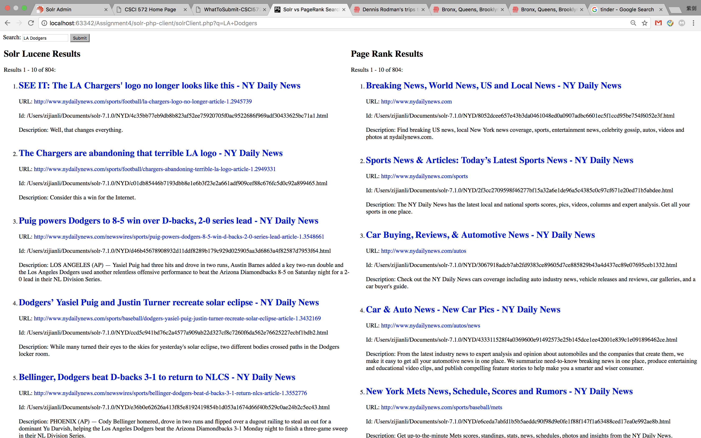 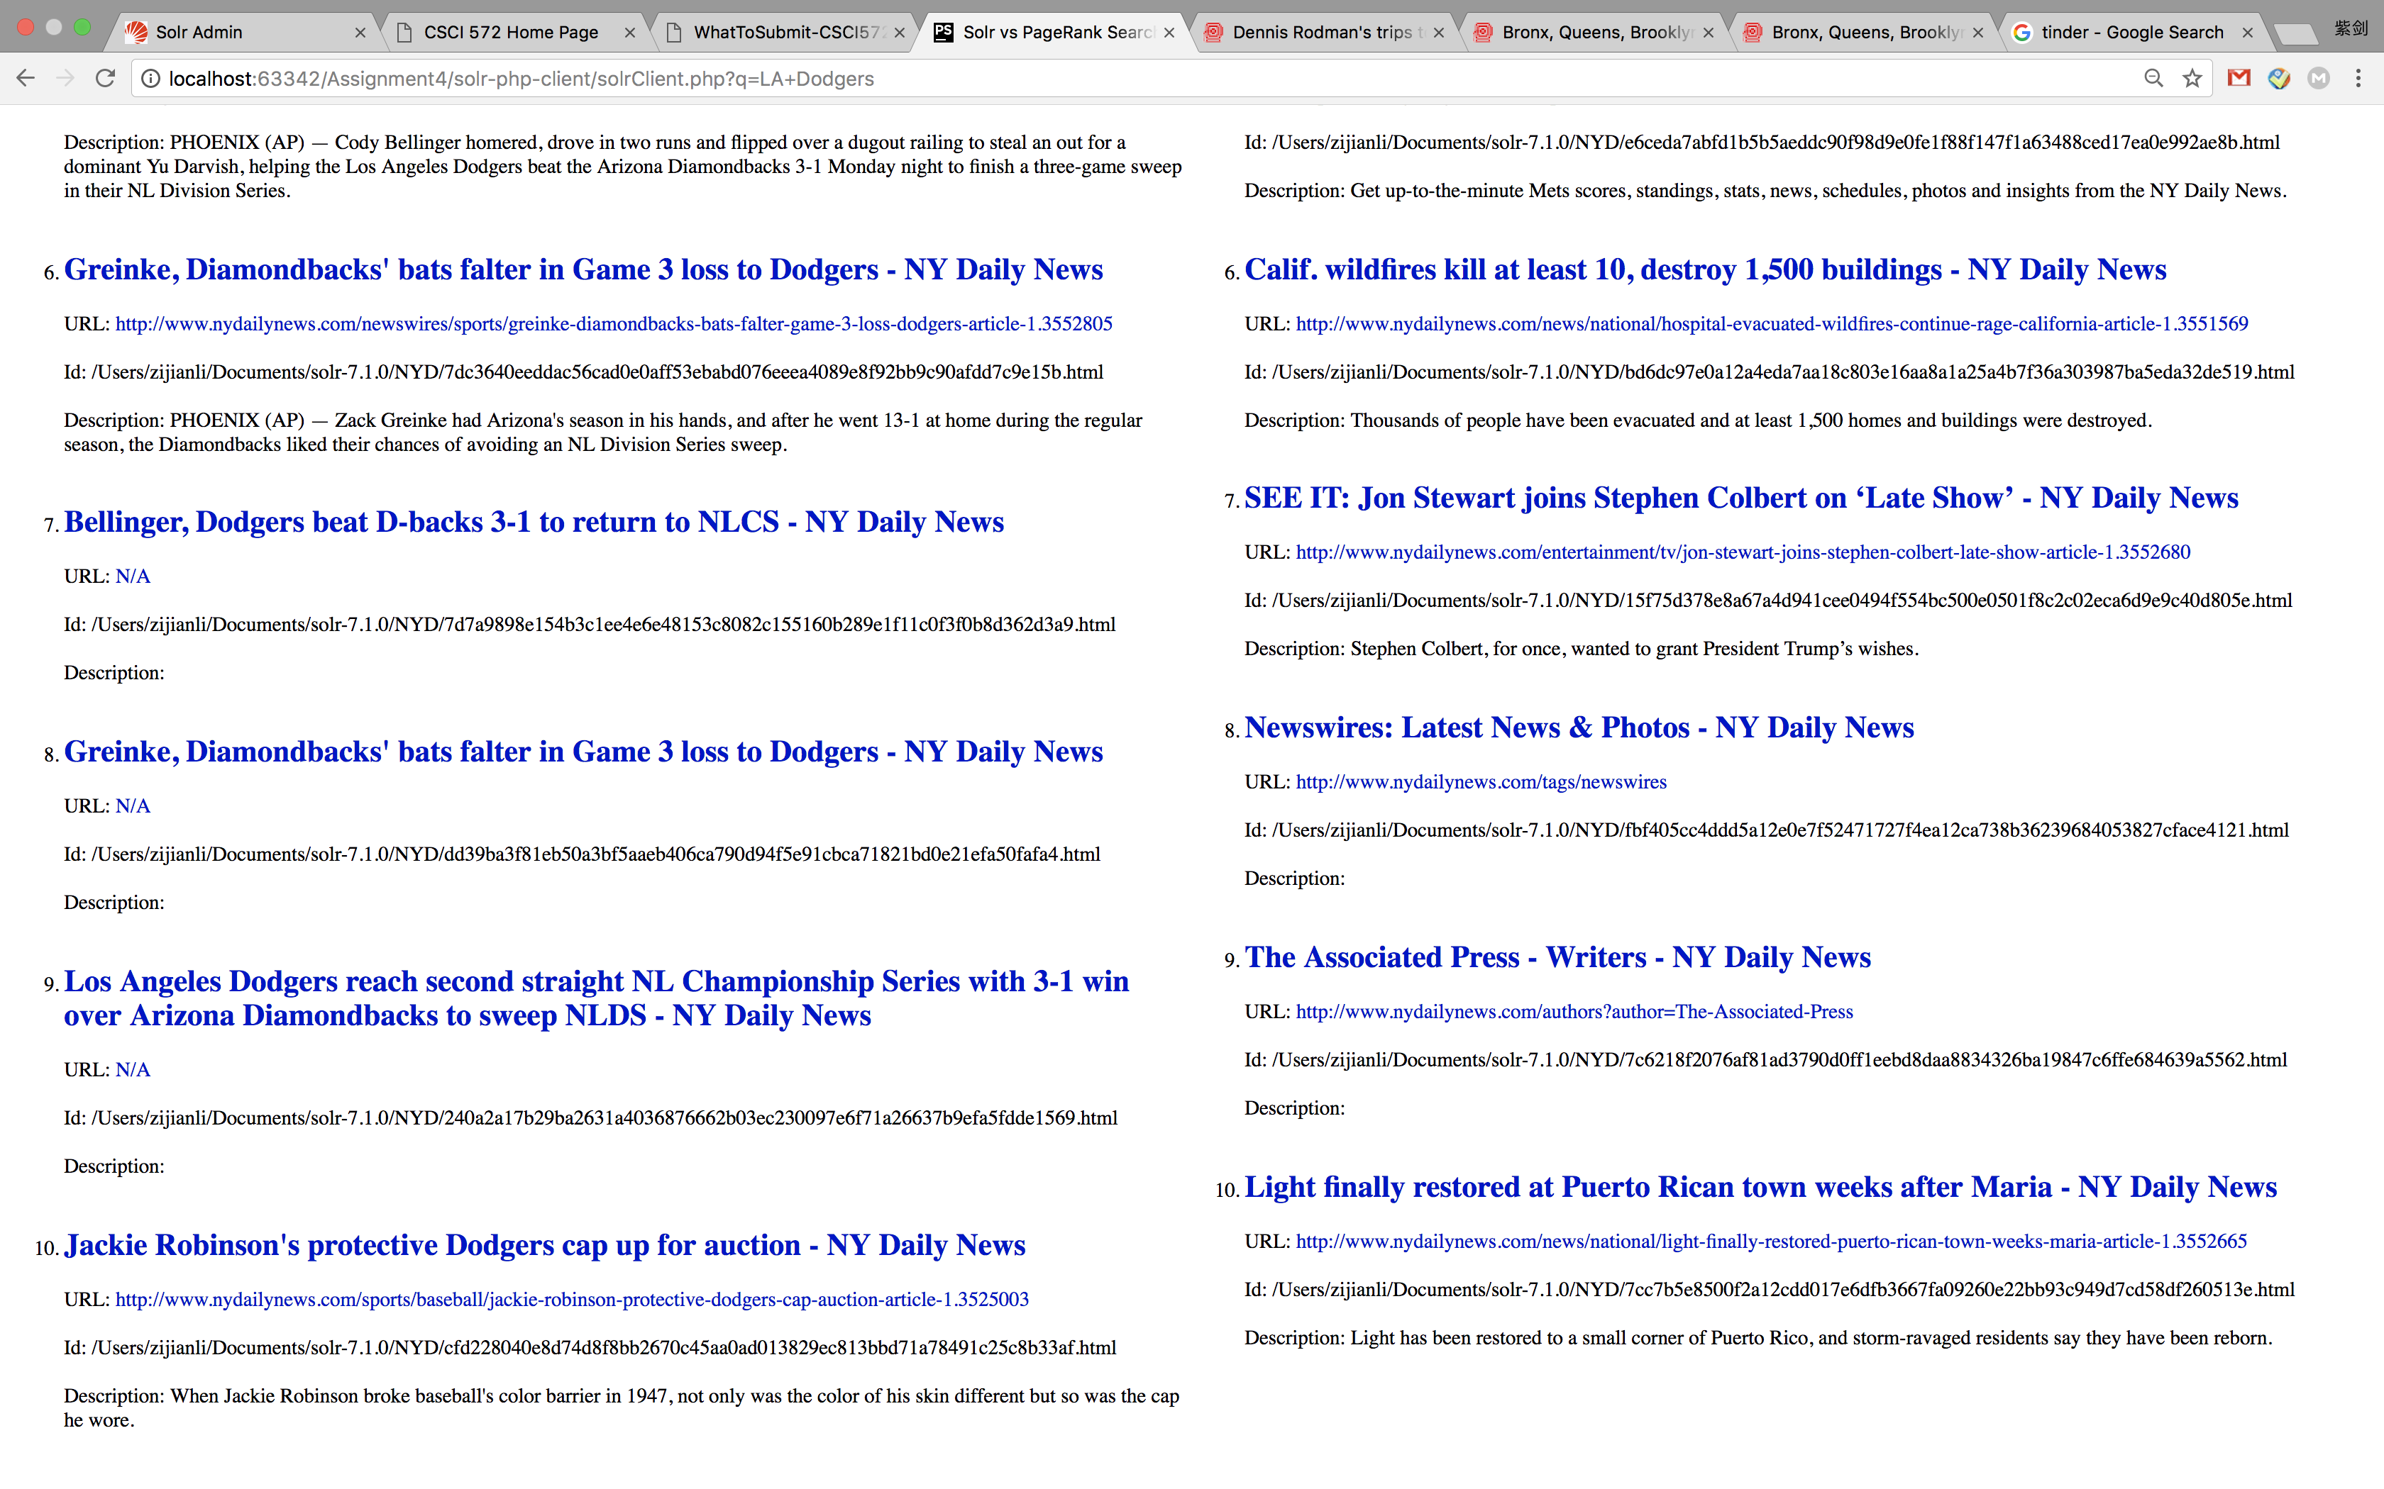

Result pages:

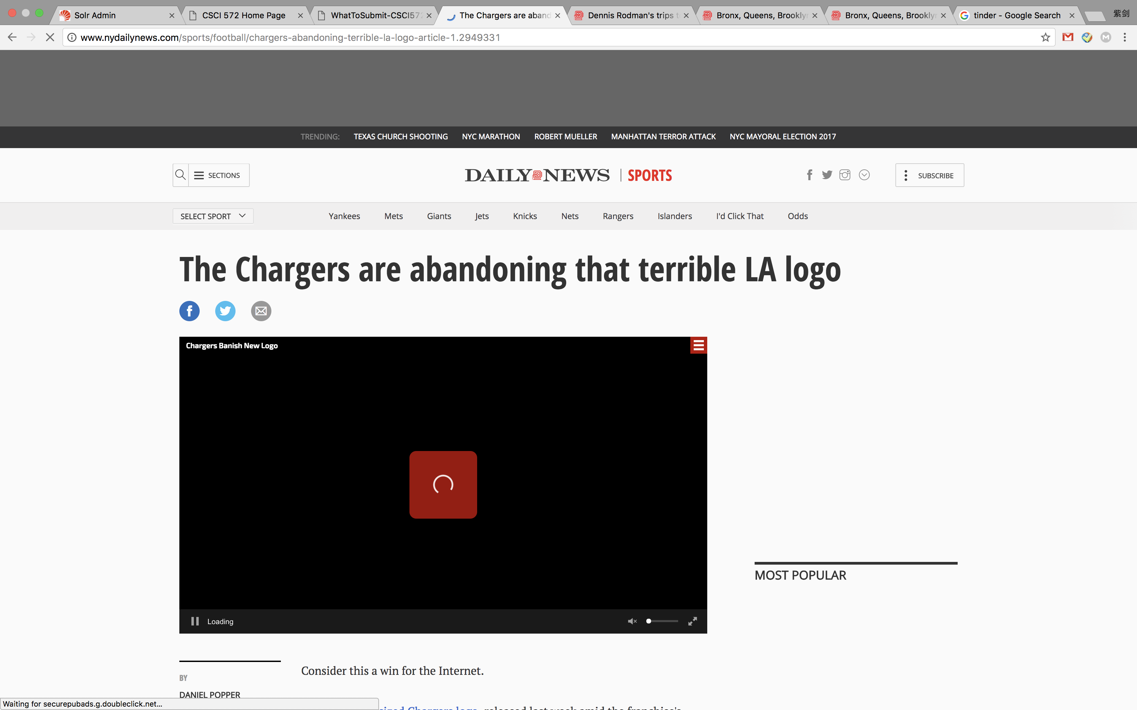

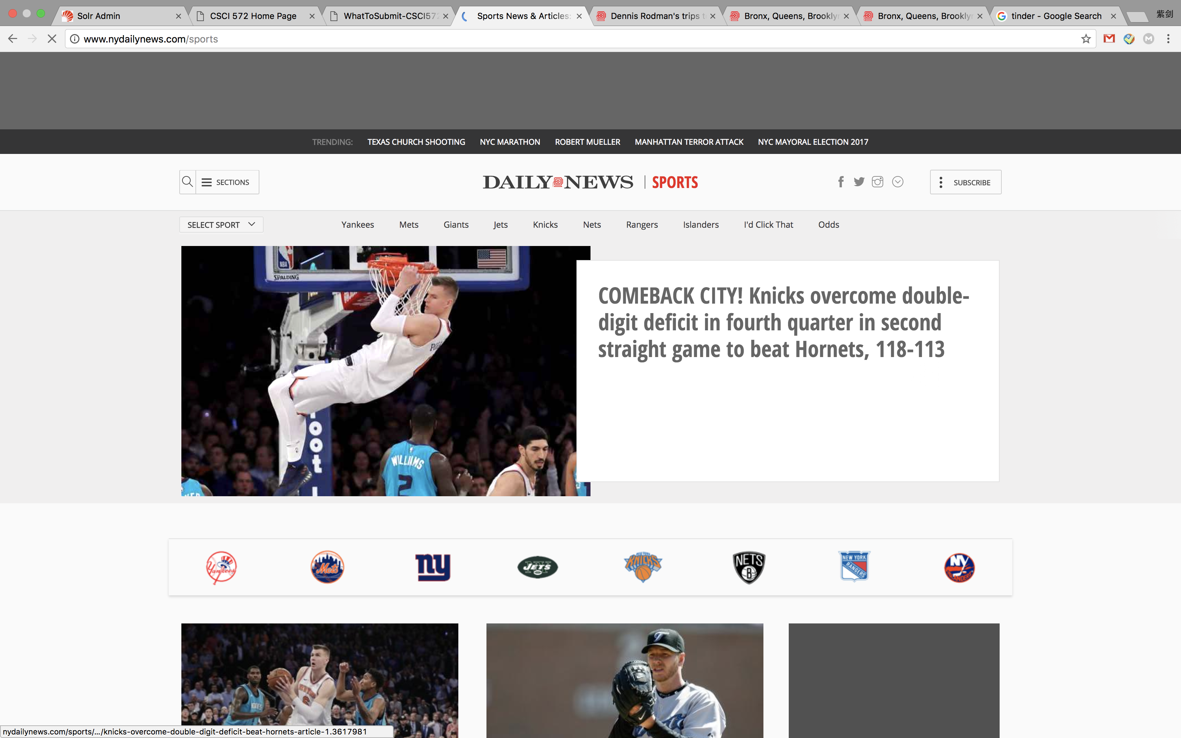

Solr Result:

1. URL: <http://www.nydailynews.com/sports/football/la-chargers-logo-no-longer-article-1.2945739>
2. URL: <http://www.nydailynews.com/sports/football/chargers-abandoning-terrible-la-logo-article-1.2949331>
3. URL: <http://www.nydailynews.com/newswires/sports/puig-powers-dodgers-8-5-win-d-backs-2-0-series-lead-article-1.3548661>
4. URL: <http://www.nydailynews.com/sports/baseball/dodgers-yasiel-puig-justin-turner-recreate-solar-eclipse-article-1.3432169>
5. URL: <http://www.nydailynews.com/newswires/sports/bellinger-dodgers-beat-d-backs-3-1-return-nlcs-article-1.3552776>
6. URL: <http://www.nydailynews.com/newswires/sports/greinke-diamondbacks-bats-falter-game-3-loss-dodgers-article-1.3552805>
7. URL: [N/A](http://localhost:63342/Assignment4/solr-php-client/N/A)
8. URL: [N/A](http://localhost:63342/Assignment4/solr-php-client/N/A)
9. URL: [N/A](http://localhost:63342/Assignment4/solr-php-client/N/A)
10. URL: <http://www.nydailynews.com/sports/baseball/jackie-robinson-protective-dodgers-cap-auction-article-1.3525003>

Page Rank resuls:

1. URL: [http://www.nydailynews.com](http://www.nydailynews.com/)
2. URL: <http://www.nydailynews.com/sports>
3. URL: <http://www.nydailynews.com/autos>
4. URL: <http://www.nydailynews.com/autos/news>
5. URL: <http://www.nydailynews.com/sports/baseball/mets>
6. URL: <http://www.nydailynews.com/news/national/hospital-evacuated-wildfires-continue-rage-california-article-1.3551569>
7. URL: <http://www.nydailynews.com/entertainment/tv/jon-stewart-joins-stephen-colbert-late-show-article-1.3552680>
8. URL: <http://www.nydailynews.com/tags/newswires>
9. URL: <http://www.nydailynews.com/authors?author=The-Associated-Press>
10. URL: <http://www.nydailynews.com/news/national/light-finally-restored-puerto-rican-town-weeks-maria-article-1.3552665>

**Puerto Rico** 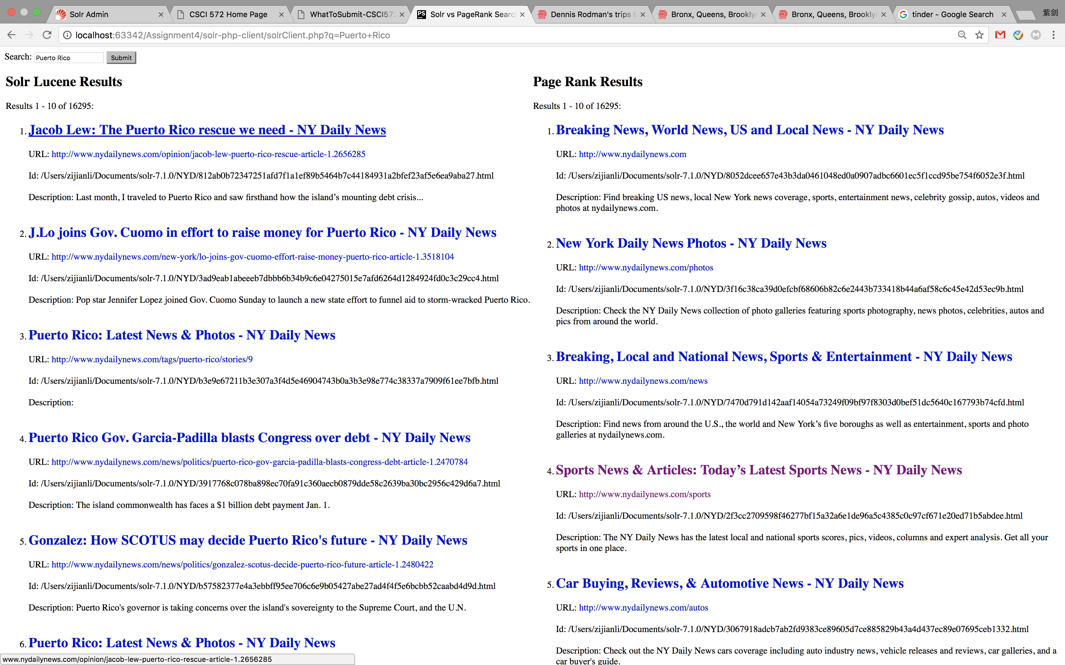 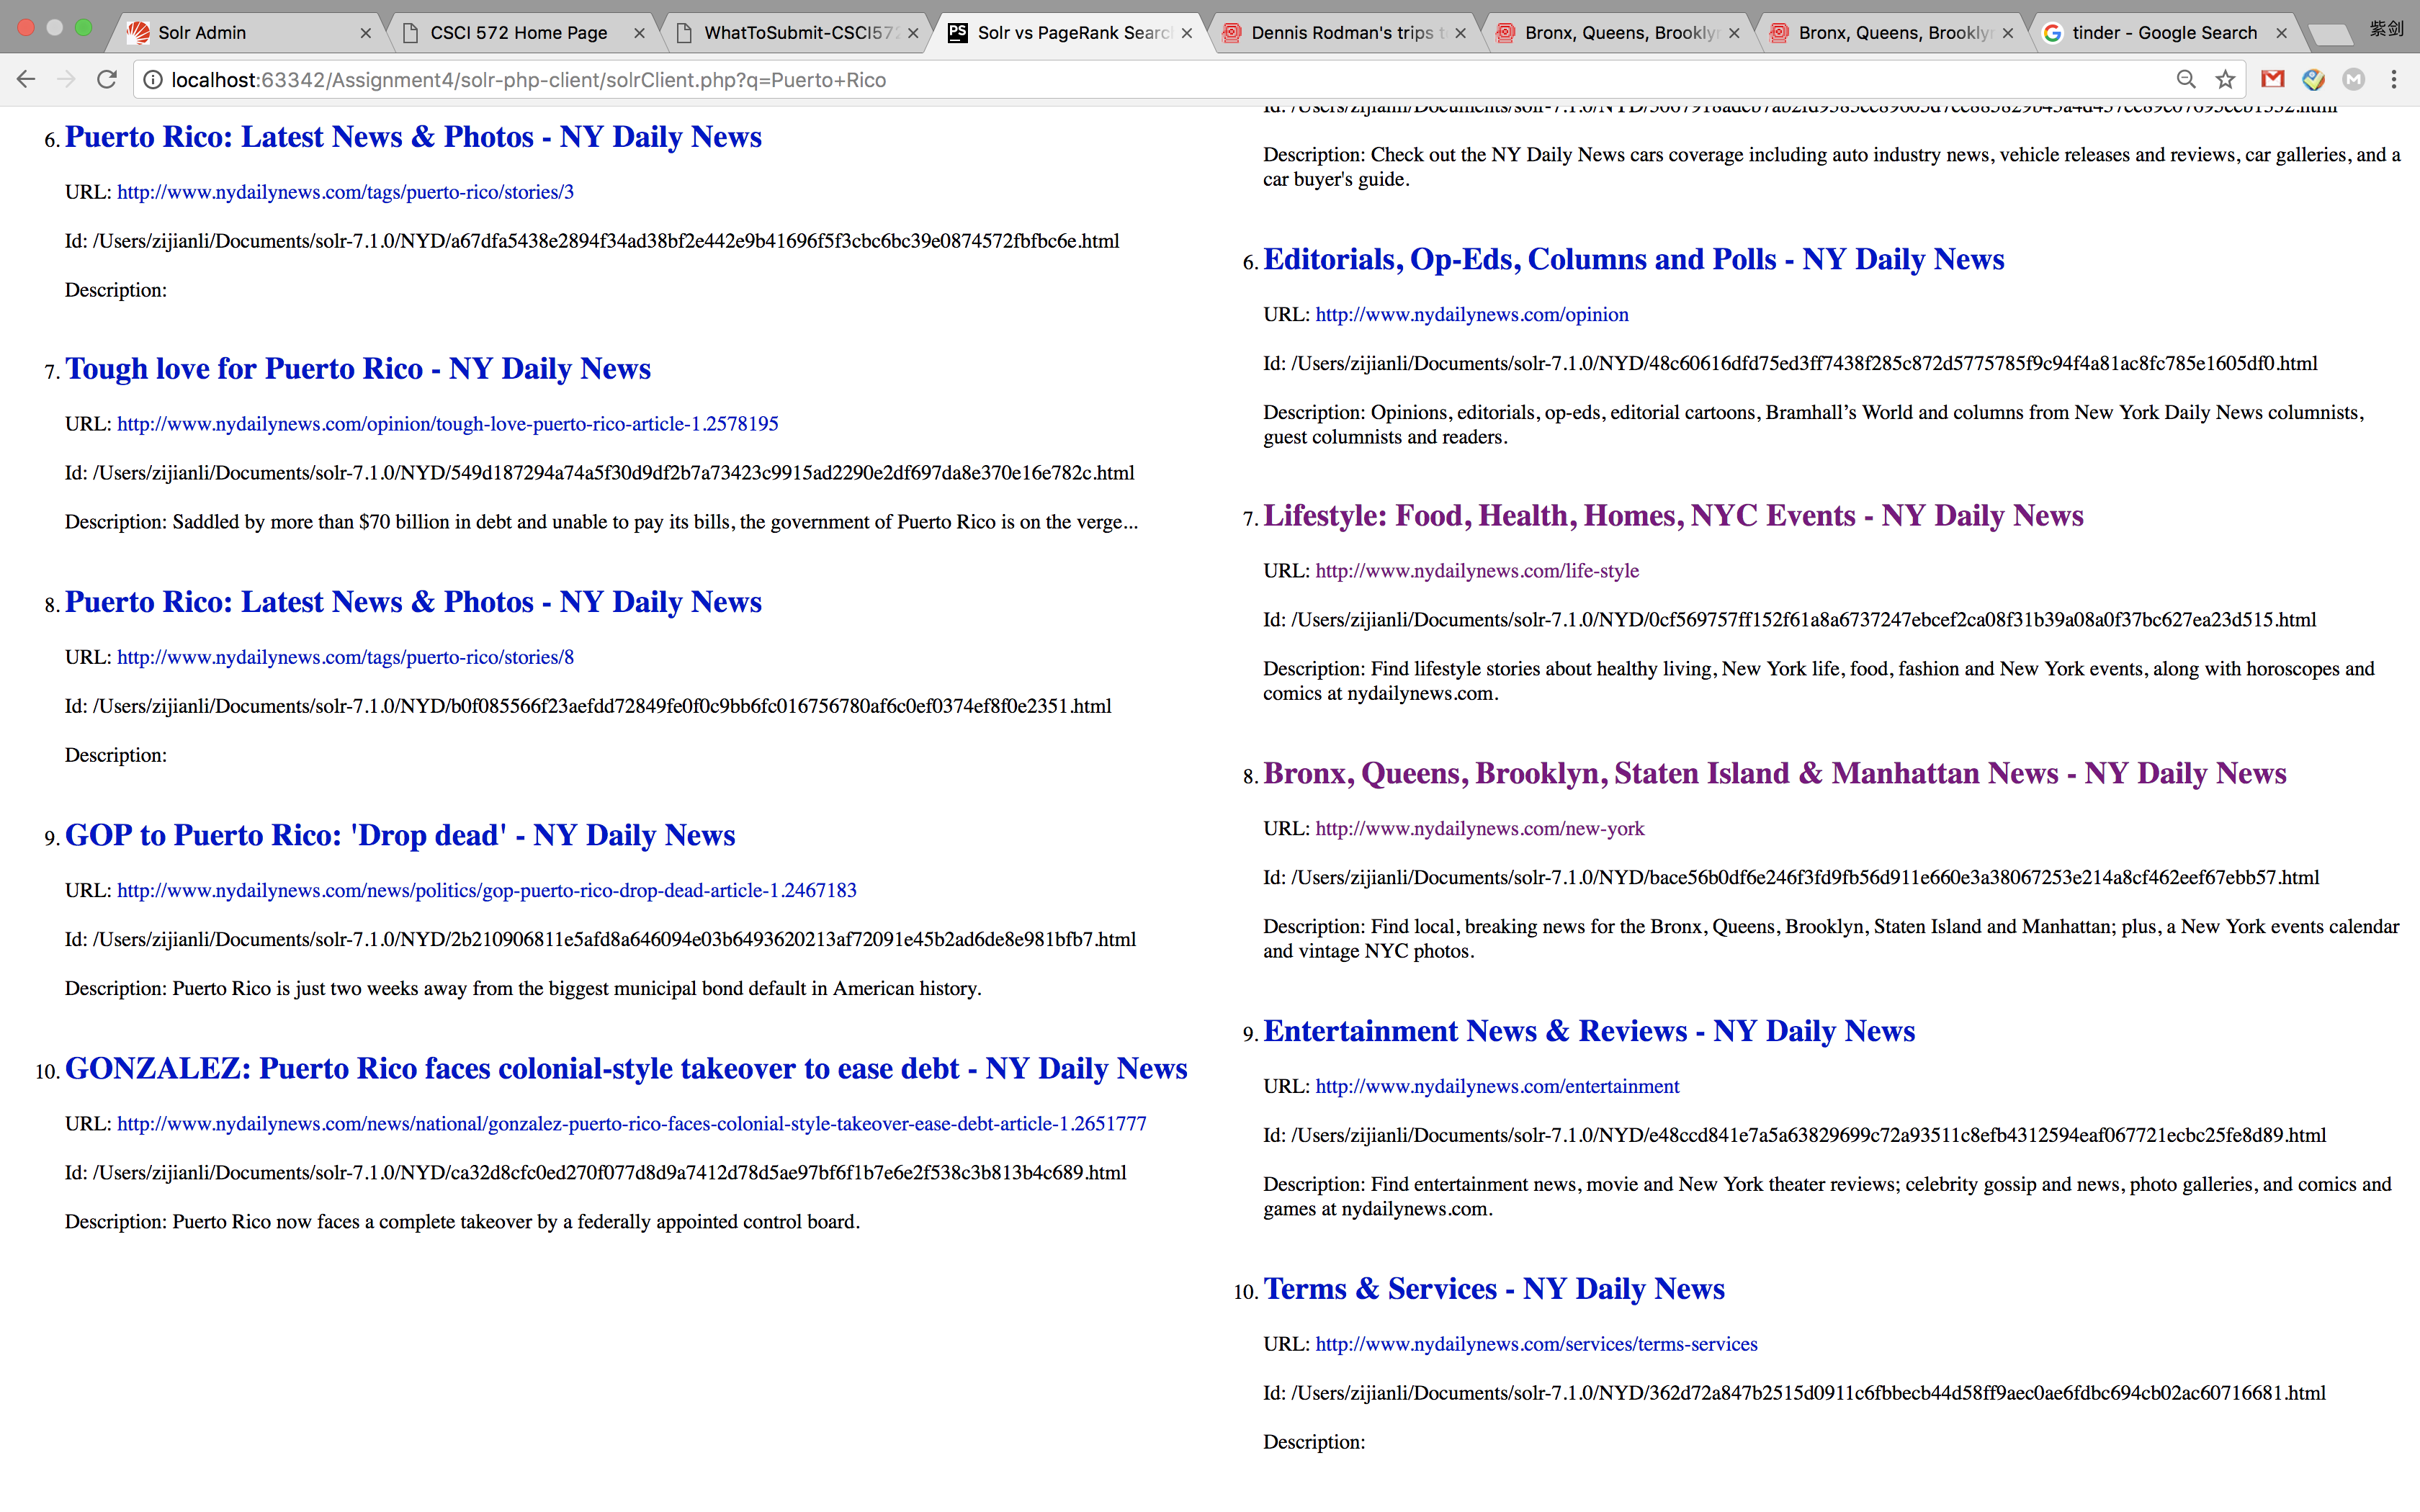

Result page:

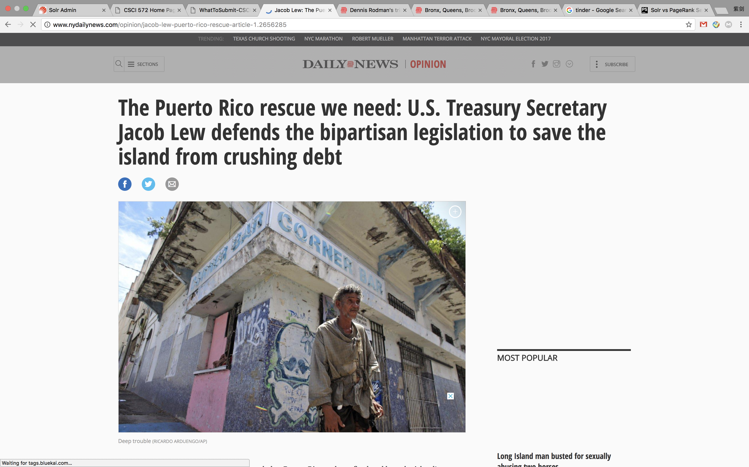 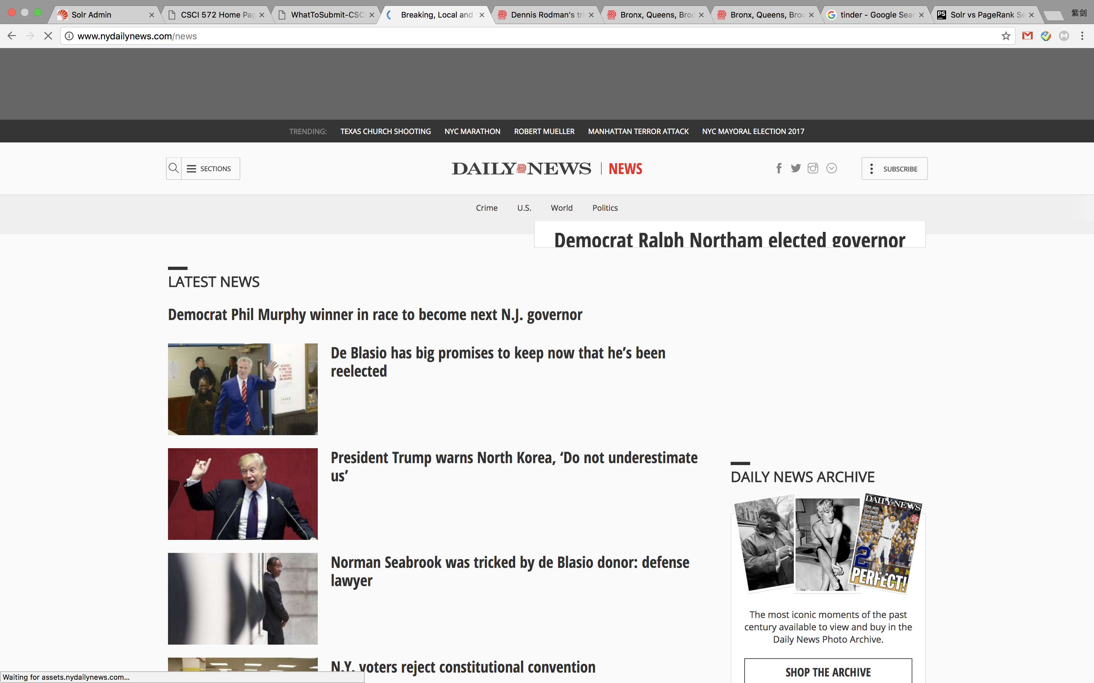

Solr Result:

1. URL: <http://www.nydailynews.com/opinion/jacob-lew-puerto-rico-rescue-article-1.2656285>
2. URL: <http://www.nydailynews.com/new-york/lo-joins-gov-cuomo-effort-raise-money-puerto-rico-article-1.3518104>
3. URL: <http://www.nydailynews.com/tags/puerto-rico/stories/9>
4. URL: <http://www.nydailynews.com/news/politics/puerto-rico-gov-garcia-padilla-blasts-congress-debt-article-1.2470784>
5. URL: <http://www.nydailynews.com/news/politics/gonzalez-scotus-decide-puerto-rico-future-article-1.2480422>
6. URL: <http://www.nydailynews.com/tags/puerto-rico/stories/3>
7. URL: <http://www.nydailynews.com/opinion/tough-love-puerto-rico-article-1.2578195>
8. URL: <http://www.nydailynews.com/tags/puerto-rico/stories/8>
9. URL: <http://www.nydailynews.com/news/politics/gop-puerto-rico-drop-dead-article-1.2467183>
10. URL: <http://www.nydailynews.com/news/national/gonzalez-puerto-rico-faces-colonial-style-takeover-ease-debt-article-1.2651777>

Page Rank:

1. URL: [http://www.nydailynews.com](http://www.nydailynews.com/)
2. URL: <http://www.nydailynews.com/photos>
3. URL: <http://www.nydailynews.com/news>
4. URL: <http://www.nydailynews.com/sports>
5. URL: <http://www.nydailynews.com/autos>
6. URL: <http://www.nydailynews.com/opinion>
7. URL: <http://www.nydailynews.com/life-style>
8. URL: <http://www.nydailynews.com/new-york>
9. URL: <http://www.nydailynews.com/entertainment>
10. URL: <http://www.nydailynews.com/services/terms-services>

**Hurricane Harvey** 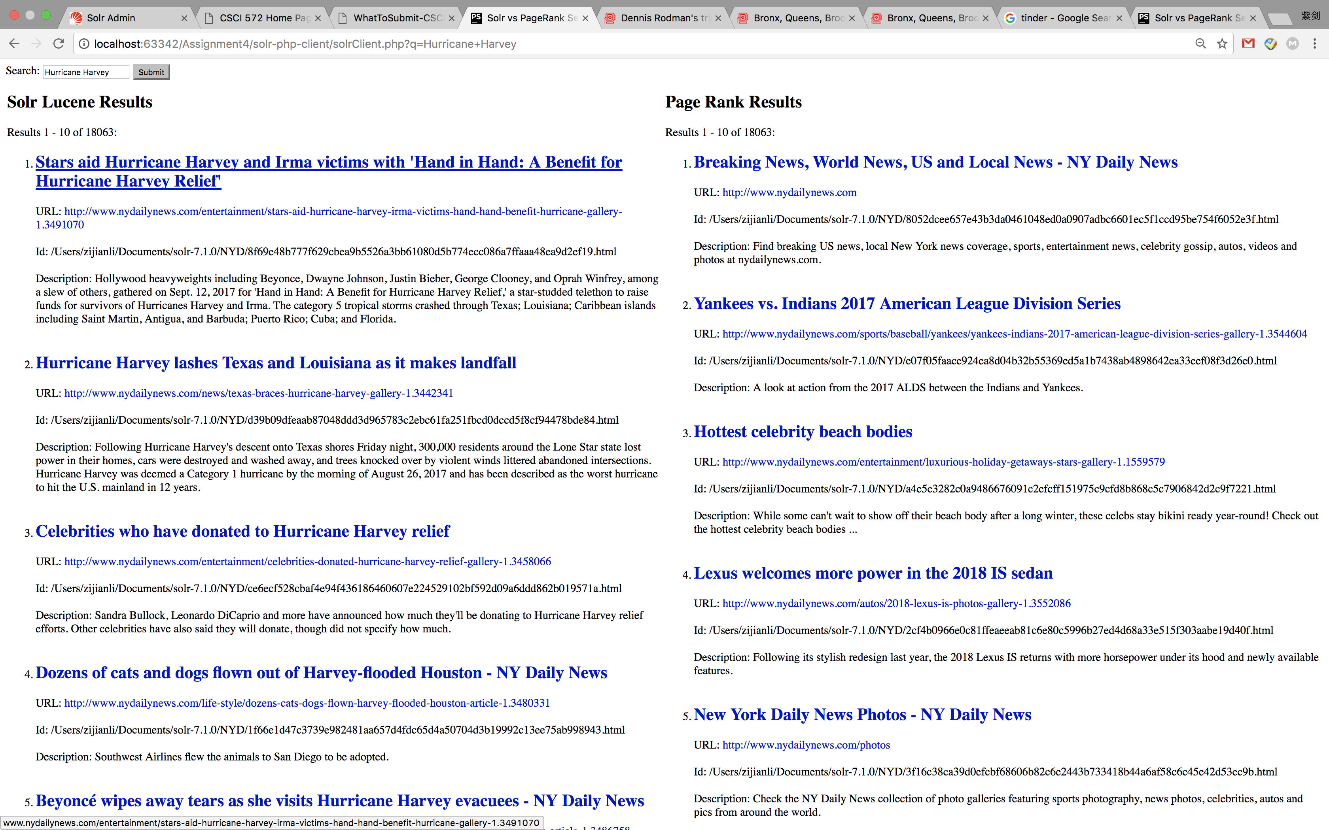 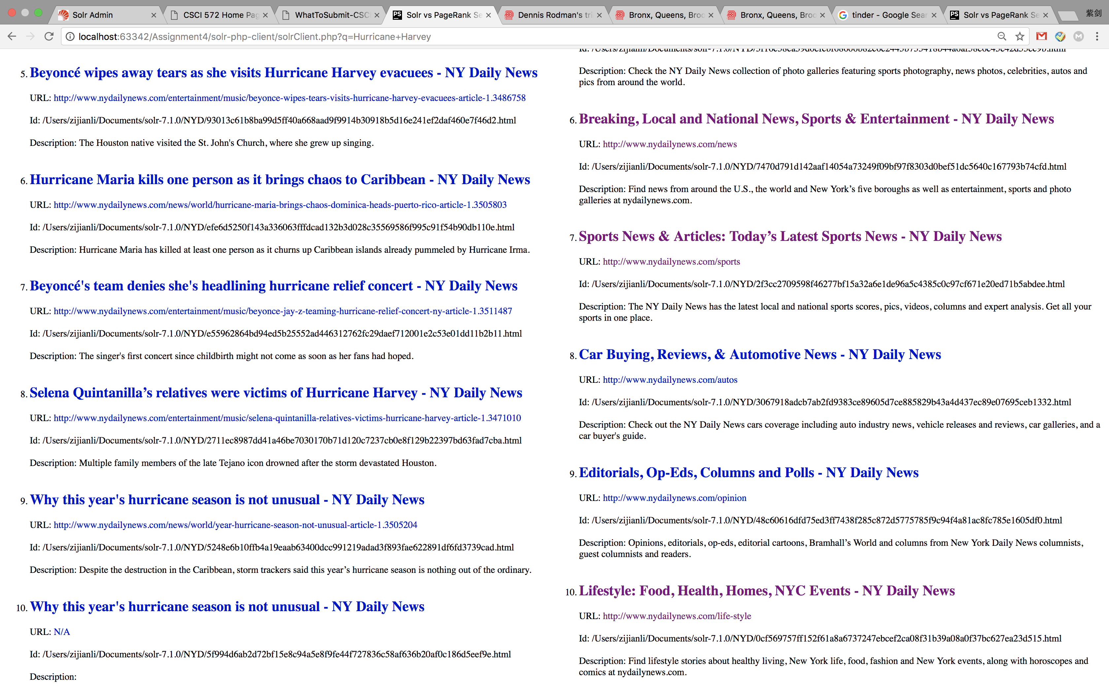

Result pages:

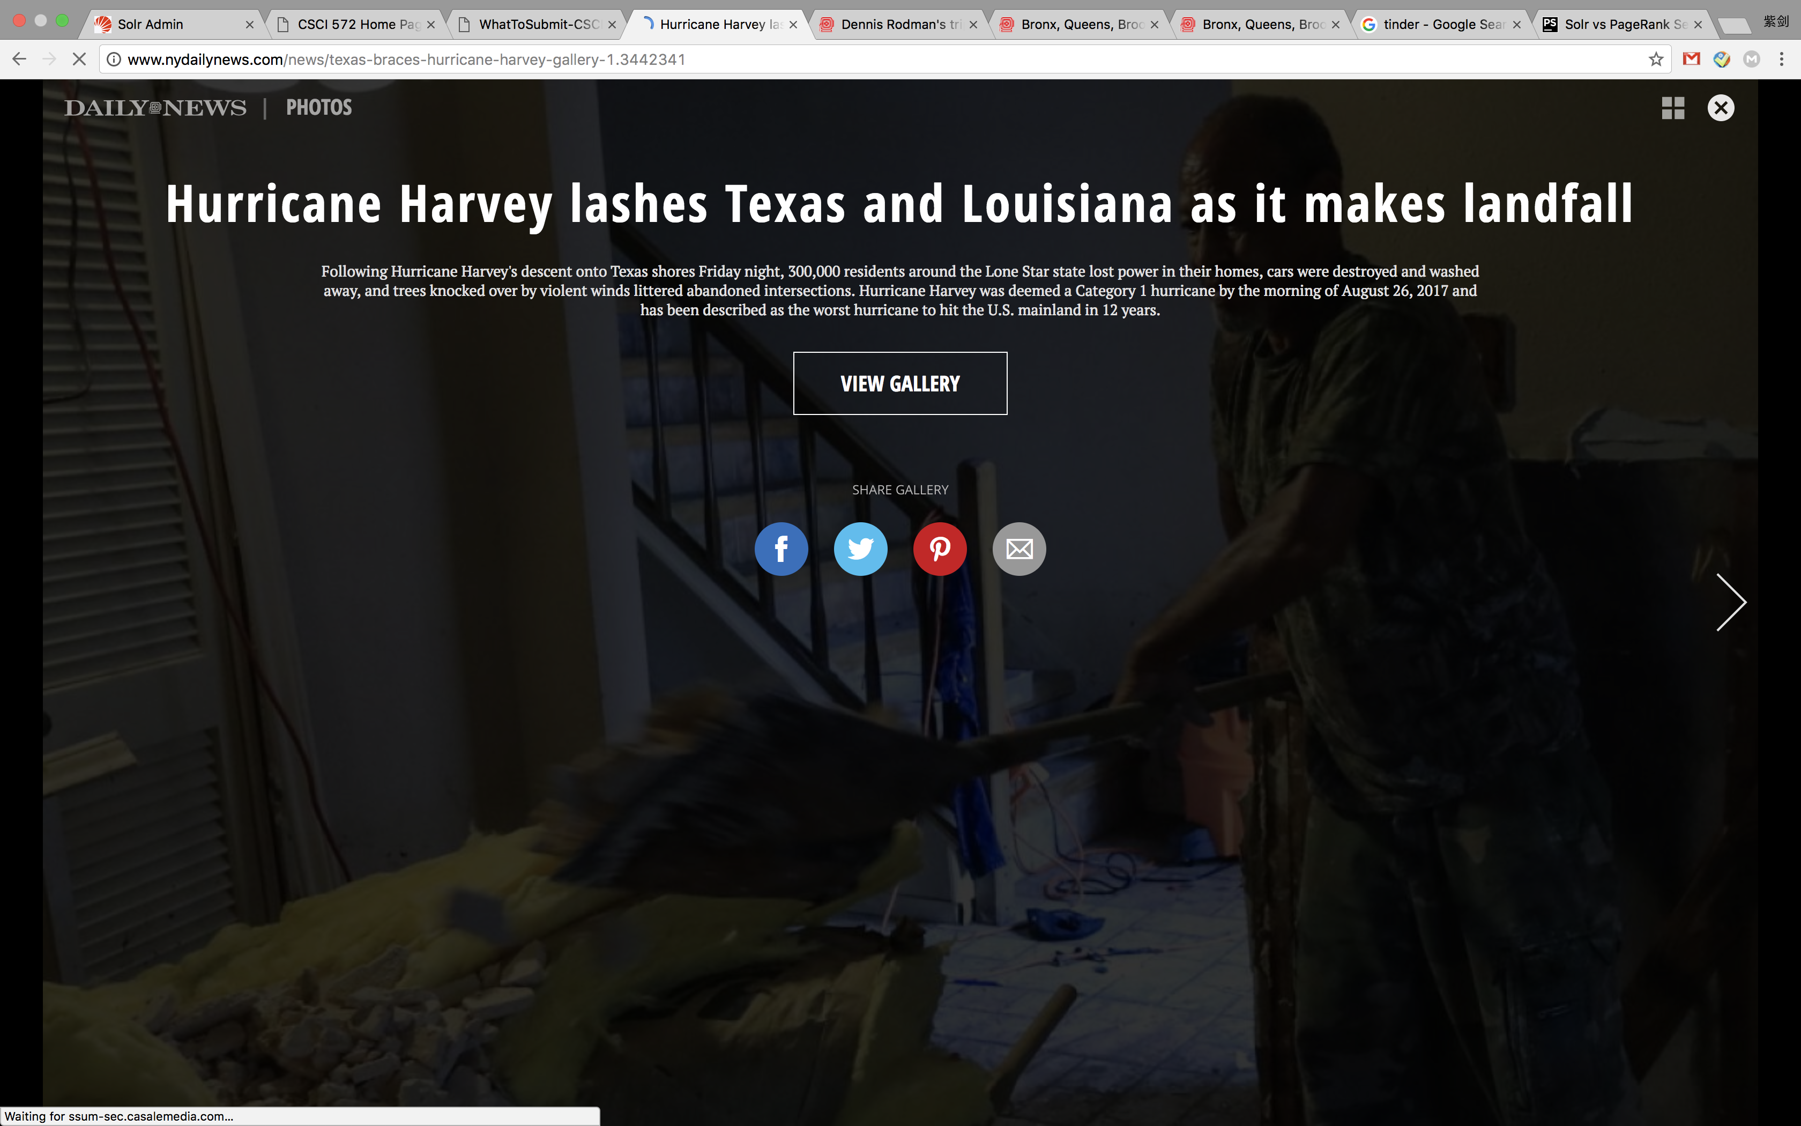 

Solr Result:

1. URL: <http://www.nydailynews.com/entertainment/stars-aid-hurricane-harvey-irma-victims-hand-hand-benefit-hurricane-gallery-1.3491070>
2. URL: <http://www.nydailynews.com/news/texas-braces-hurricane-harvey-gallery-1.3442341>
3. URL: <http://www.nydailynews.com/entertainment/celebrities-donated-hurricane-harvey-relief-gallery-1.3458066>
4. URL: <http://www.nydailynews.com/life-style/dozens-cats-dogs-flown-harvey-flooded-houston-article-1.3480331>
5. URL: <http://www.nydailynews.com/entertainment/music/beyonce-wipes-tears-visits-hurricane-harvey-evacuees-article-1.3486758>
6. URL: <http://www.nydailynews.com/news/world/hurricane-maria-brings-chaos-dominica-heads-puerto-rico-article-1.3505803>
7. URL: <http://www.nydailynews.com/entertainment/music/beyonce-jay-z-teaming-hurricane-relief-concert-ny-article-1.3511487>
8. URL: <http://www.nydailynews.com/entertainment/music/selena-quintanilla-relatives-victims-hurricane-harvey-article-1.3471010>
9. URL: <http://www.nydailynews.com/news/world/year-hurricane-season-not-unusual-article-1.3505204>
10. URL: [N/A](http://localhost:63342/Assignment4/solr-php-client/N/A)

Page rank:

1. URL: [http://www.nydailynews.com](http://www.nydailynews.com/)
2. URL: <http://www.nydailynews.com/sports/baseball/yankees/yankees-indians-2017-american-league-division-series-gallery-1.3544604>
3. URL: <http://www.nydailynews.com/entertainment/luxurious-holiday-getaways-stars-gallery-1.1559579>
4. URL: <http://www.nydailynews.com/autos/2018-lexus-is-photos-gallery-1.3552086>
5. URL: <http://www.nydailynews.com/photos>
6. URL: <http://www.nydailynews.com/news>
7. URL: <http://www.nydailynews.com/sports>
8. URL: <http://www.nydailynews.com/autos>
9. URL: <http://www.nydailynews.com/opinion>
10. URL: <http://www.nydailynews.com/life-style>

**iPhone X** 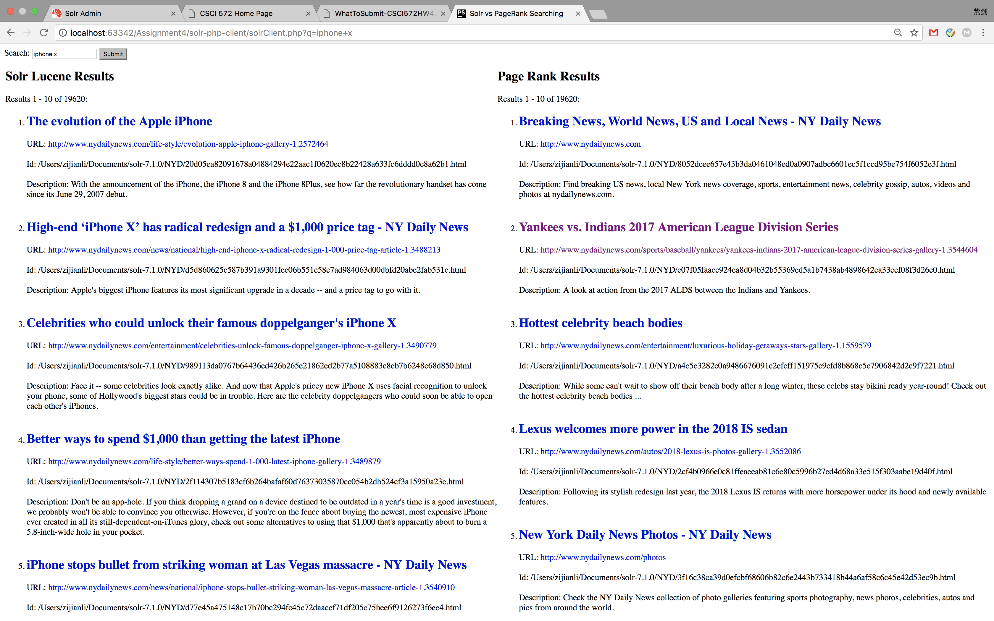 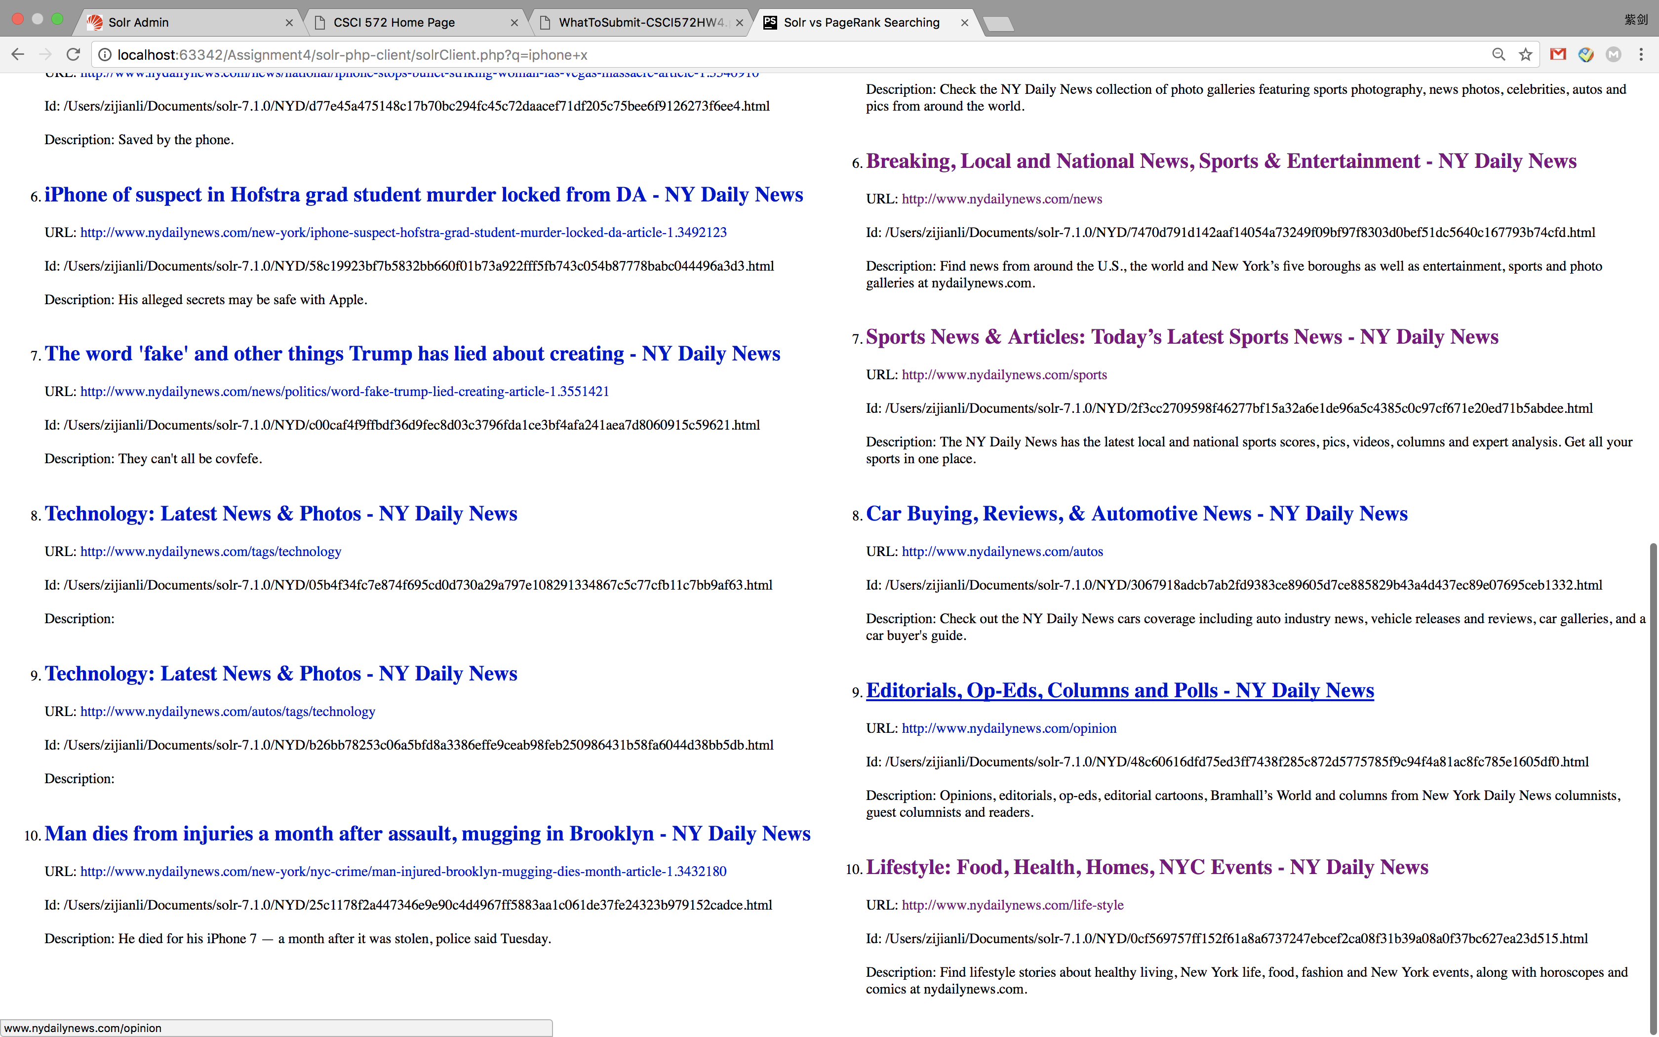

Result Page:

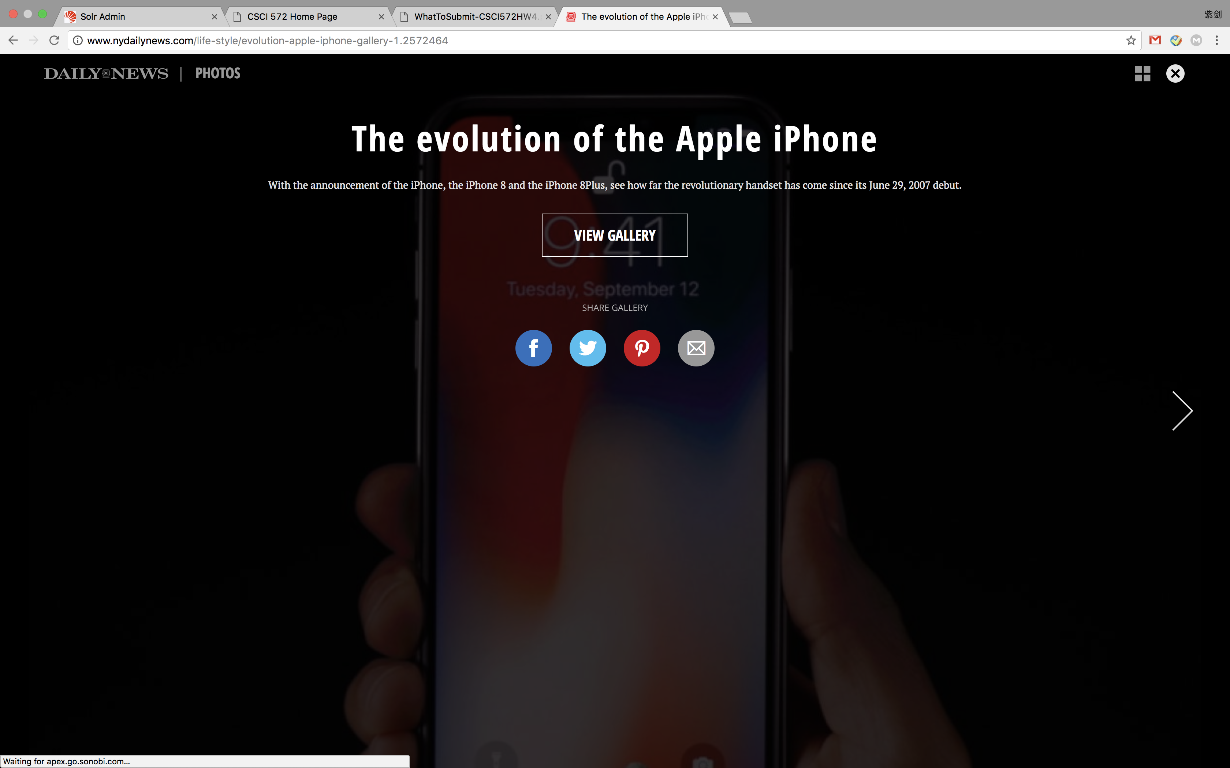 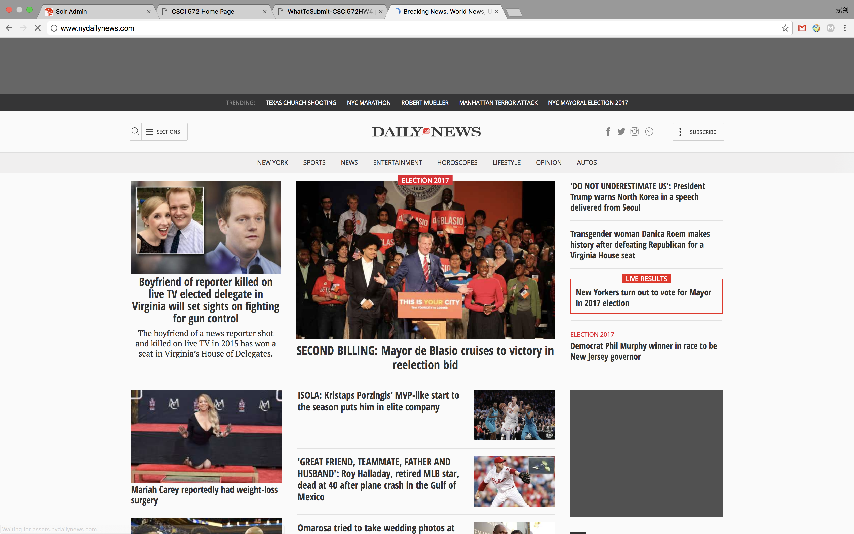

Solr results:

1. URL: <http://www.nydailynews.com/life-style/evolution-apple-iphone-gallery-1.2572464>
2. URL: <http://www.nydailynews.com/news/national/high-end-iphone-x-radical-redesign-1-000-price-tag-article-1.3488213>
3. URL: <http://www.nydailynews.com/entertainment/celebrities-unlock-famous-doppelganger-iphone-x-gallery-1.3490779>
4. URL: <http://www.nydailynews.com/life-style/better-ways-spend-1-000-latest-iphone-gallery-1.3489879>
5. URL: <http://www.nydailynews.com/news/national/iphone-stops-bullet-striking-woman-las-vegas-massacre-article-1.3540910>
6. URL: <http://www.nydailynews.com/new-york/iphone-suspect-hofstra-grad-student-murder-locked-da-article-1.3492123>
7. URL: <http://www.nydailynews.com/news/politics/word-fake-trump-lied-creating-article-1.3551421>
8. URL: <http://www.nydailynews.com/tags/technology>
9. URL: <http://www.nydailynews.com/autos/tags/technology>
10. URL: <http://www.nydailynews.com/new-york/nyc-crime/man-injured-brooklyn-mugging-dies-month-article-1.3432180>

Page rank:

1. URL: [http://www.nydailynews.com](http://www.nydailynews.com/)
2. URL: <http://www.nydailynews.com/sports/baseball/yankees/yankees-indians-2017-american-league-division-series-gallery-1.3544604>
3. URL: <http://www.nydailynews.com/entertainment/luxurious-holiday-getaways-stars-gallery-1.1559579>
4. URL: <http://www.nydailynews.com/autos/2018-lexus-is-photos-gallery-1.3552086>
5. URL: <http://www.nydailynews.com/photos>
6. URL: <http://www.nydailynews.com/news>
7. URL: <http://www.nydailynews.com/sports>
8. URL: <http://www.nydailynews.com/autos>
9. URL: <http://www.nydailynews.com/opinion>
10. URL: <http://www.nydailynews.com/life-style>

**Paris Climate Deal**

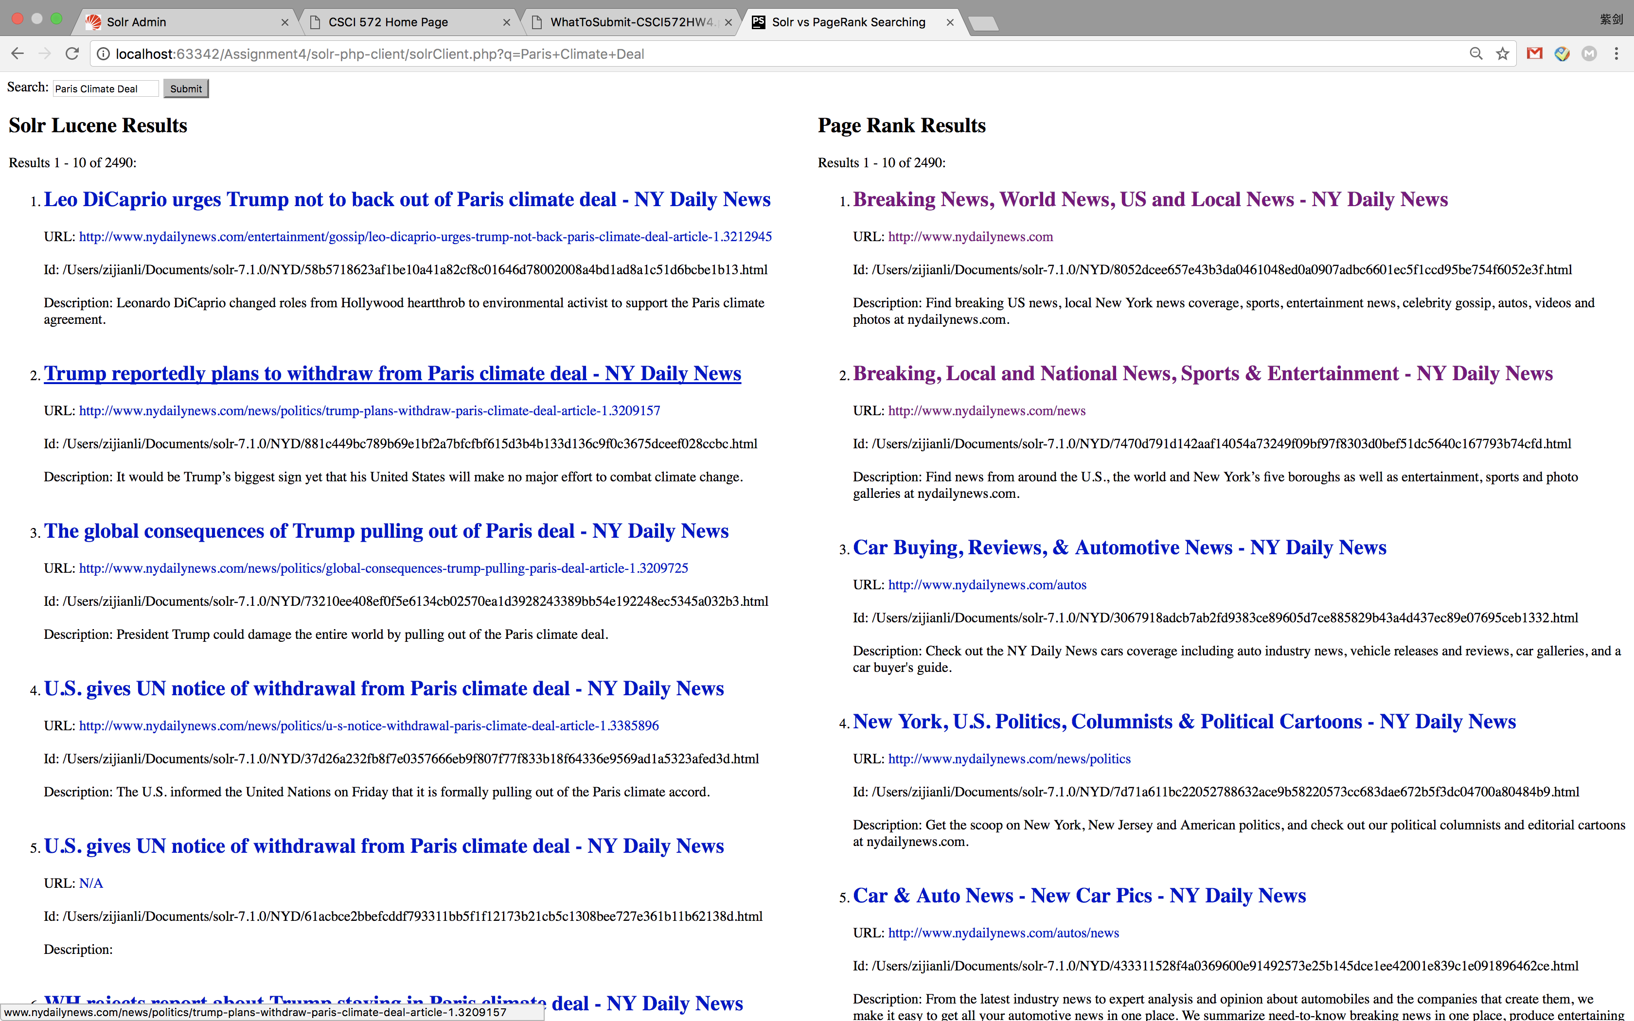 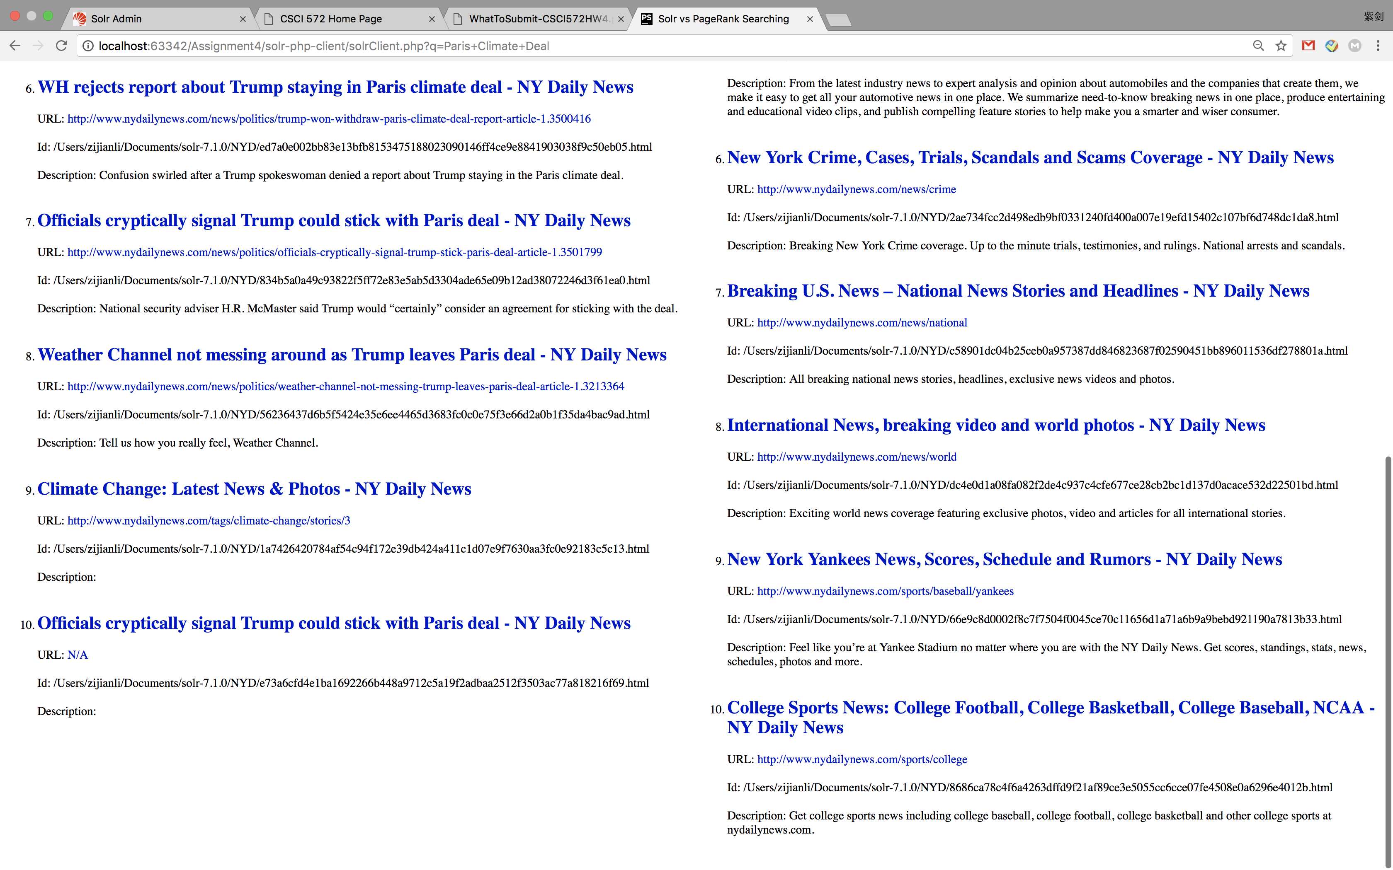

Result pages:

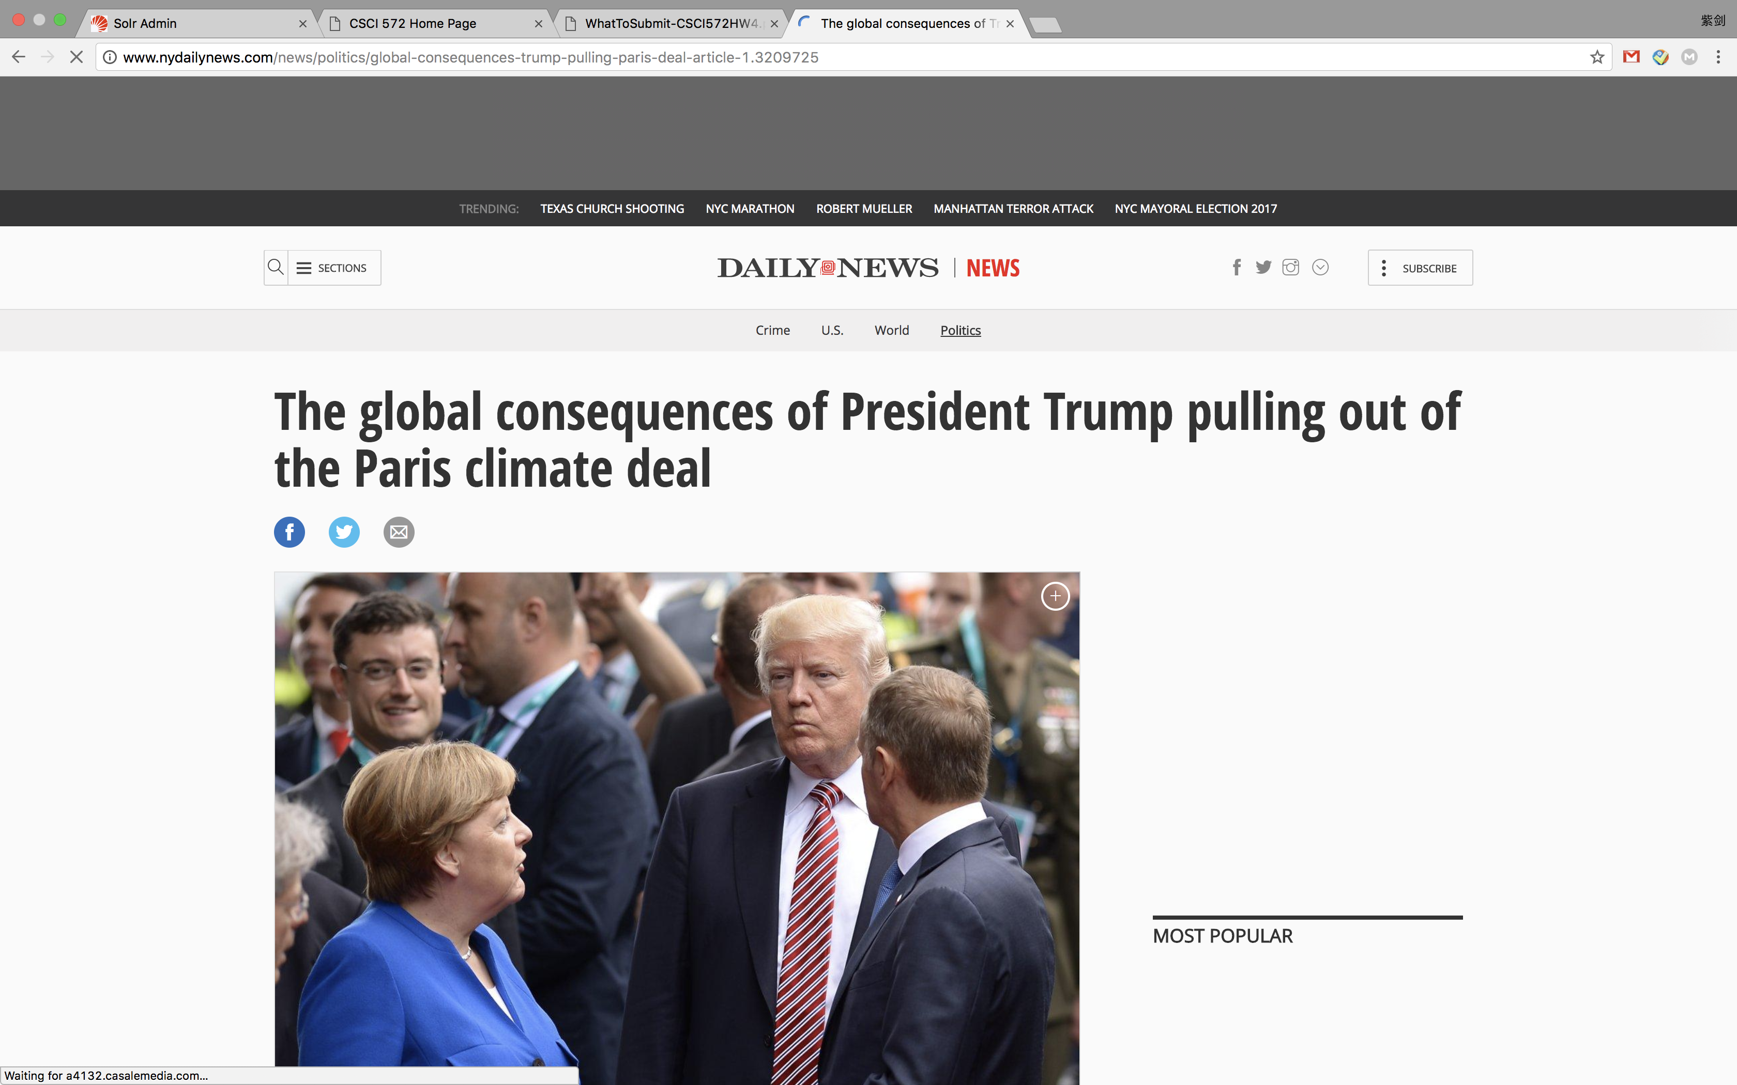 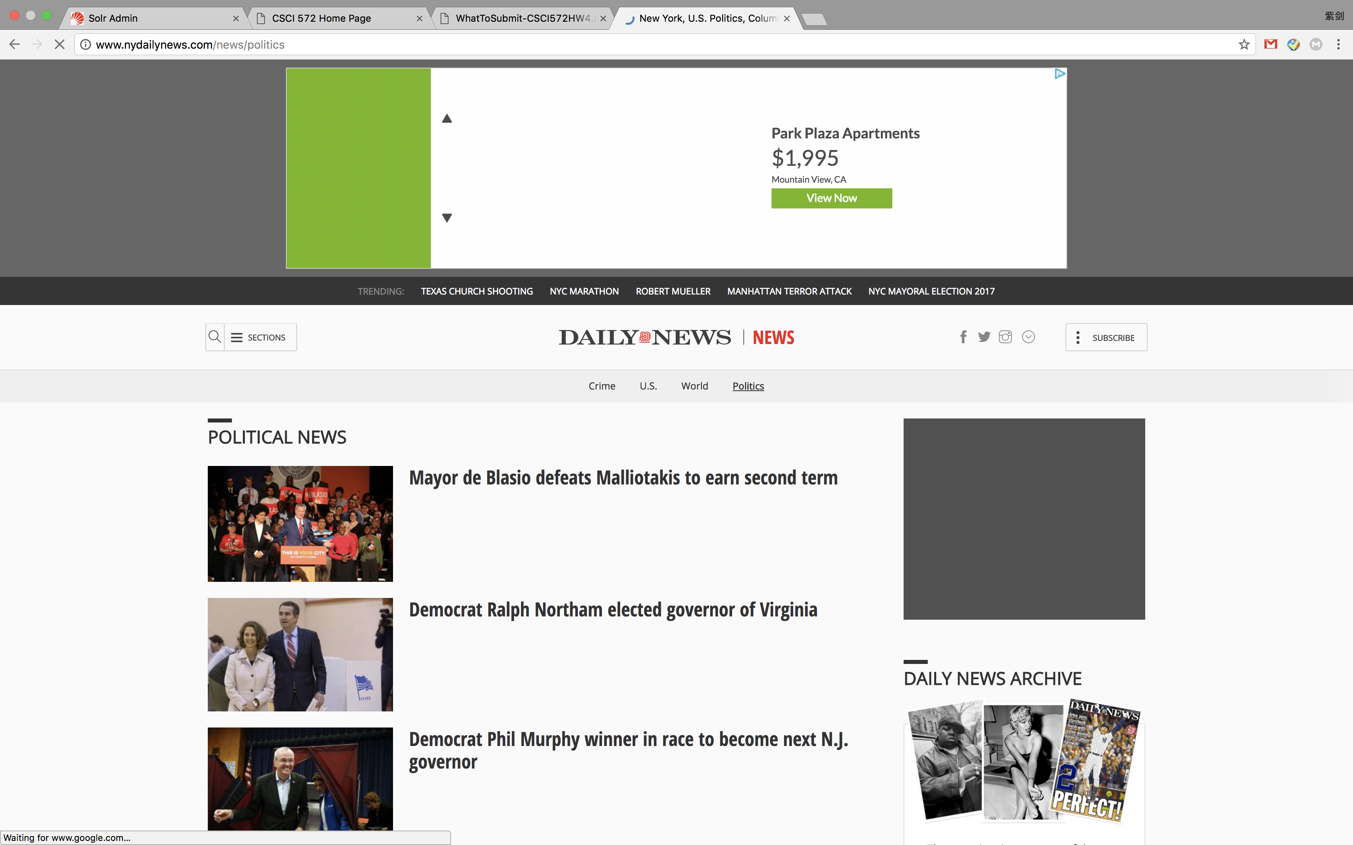

Solr Results:

1. URL: <http://www.nydailynews.com/entertainment/gossip/leo-dicaprio-urges-trump-not-back-paris-climate-deal-article-1.3212945>
2. URL: <http://www.nydailynews.com/news/politics/trump-plans-withdraw-paris-climate-deal-article-1.3209157>
3. URL: <http://www.nydailynews.com/news/politics/global-consequences-trump-pulling-paris-deal-article-1.3209725>
4. URL: <http://www.nydailynews.com/news/politics/u-s-notice-withdrawal-paris-climate-deal-article-1.3385896>
5. URL: [N/A](http://localhost:63342/Assignment4/solr-php-client/N/A)
6. URL: <http://www.nydailynews.com/news/politics/trump-won-withdraw-paris-climate-deal-report-article-1.3500416>
7. URL: <http://www.nydailynews.com/news/politics/officials-cryptically-signal-trump-stick-paris-deal-article-1.3501799>
8. URL: <http://www.nydailynews.com/news/politics/weather-channel-not-messing-trump-leaves-paris-deal-article-1.3213364>
9. URL: <http://www.nydailynews.com/tags/climate-change/stories/3>
10. URL: [N/A](http://localhost:63342/Assignment4/solr-php-client/N/A)

Page rank results:

1. URL: [http://www.nydailynews.com](http://www.nydailynews.com/)
2. URL: <http://www.nydailynews.com/news>
3. URL: <http://www.nydailynews.com/autos>
4. URL: <http://www.nydailynews.com/news/politics>
5. URL: <http://www.nydailynews.com/autos/news>
6. URL: <http://www.nydailynews.com/news/crime>
7. URL: <http://www.nydailynews.com/news/national>
8. URL: <http://www.nydailynews.com/news/world>
9. URL: <http://www.nydailynews.com/sports/baseball/yankees>
10. URL: <http://www.nydailynews.com/sports/college>

**Overlapping:**

**For all the eight queries I entered into the web pages, Solr internal results and page rank results have no overlaps in any of them.**